**JPG Grayscale Image Edge Detector**

**Design Review**

Submission Date: 05/02/2018

Thursday 14:30 Lab (Lab Section 11)

TA: Reena Elangovan

**Prepared by:**

Ni Kang

Haoming Zhang

Haobo Chen

**1. Executive Summary**

Edge detection is a basic problem for image processing and computer visualization, whose aim is to denote the points which change obviously in digital image. The obvious changes in image properties usually reflect the property’s important events and changes, which includes: discontinuity in depth, discontinuity on surface, the changes in matter properties and the brightness change in a specific scenario. Image edge detection drastically decreases the number of data and eliminates the irrelevant information which keeps the important properties of the image structure. There are a lot of ways to be used in edge detection, and they can be divided into two parts. The first part is to find the maximum and minimum value in the first derivation of the image. The second part is to find the edge through find the second derivation of the image. This result in a large amount of arithmetic and repeated processing, which, makes an ASIC design a perfect fit for the purpose. In addition, having a SoC design produced specifically for them function described above will drastically diminish the workload for processing images.

The successful design of the proposed edge detector will require the following resources:

* Reference Standard Cell Simulation Library for Mapped Design Verification
* Reference Standard Cell Technology Library for Final Design Layout Verification
* Verilog HDL Simulation and Design Synthesis Tool Chain

The following documents will describe:

* Super high level block diagram of edge detection
* Edge detector address mapping
* Design pinout
* Design architecture

**2. Design Specifications**

***2.1. System Usage***

***2.1.1. System Usage Diagram***

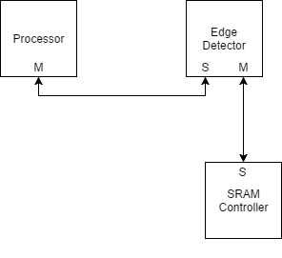

*Figure 1: Example System Usage Diagram for Edge Detector*

An example system illustrating the intended use of this edge detector is depicted above in Figure 1. In this system there is a main processor where any relevant software would be executed, SRAM where any intermediate values are stored in and edge detector for handling large scale calculation. The key operational ideas are that the software running on the processor would perform the following steps:

1. Configure the operational settings directly on the edge detector

3. Directly send the image data to the edge detector

4. Wait until edge detector’s completion status bit is asserted

5. Output the calculated result to the data bus

***2.1.2. Implemented Standard(s) and Algorithm(s)***

**Edge Detector**

Slave whose input is controlled by the processor

Sublaminar master that controls read and writing data to the SRAM

***2.1.3. Edge Detector Namespace Address Mapping***

|  |  |  |  |
| --- | --- | --- | --- |
| Slave Word | Address Read / Write | Data Size (Byte) | Description |
| 0x000 | R/W | 1 | Config bit indicating that the process is ready to start  1 -> ready  0 -> not ready |
| 0x001 | R | 4 | Input Image Data Starting Location 1 |

*Table 1: Namespace Address Mapping Table*

***2.2. Design Pinout***

|  |  |  |  |
| --- | --- | --- | --- |
| Signal Name | Direction | Number of bits | Description |
| vcc | PWR | / | Power Pin |
| gnd | GND | / | Ground Pin |
| clk | IN | 1 | System clock(500MHz) |
| n_rst | IN | 1 | Asynchronous Reset. (Active Low) |

*Table 2: Miscellaneous Pinout Table*

|  |  |  |  |
| --- | --- | --- | --- |
| Signal Name | Direction | Number of bits | Description |
| image_data | IN | 8 | Single pixel image input |
| process_done | OUT | 1 | Set to high when process finished |
| image_out | OUT | 8 | Single pixel image output |
| start | IN | 1 | Set to high when all configuration information is ready so that the data is ready to be processed |

*Table 3: System Interface Pins (In testbench)*

***2.3. Operational Characteristics***

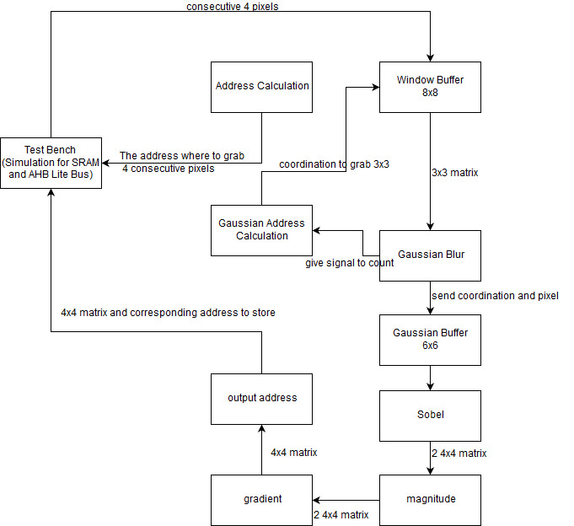

*Figure2: Total design macro behavior flow diagram*

The figure above is the total design macro behavior flow diagram. The start address will be sent to the address calculation block and the address calculation block will send the address where to grab the consecutive 4 bytes of data to the test bench where we simulated the SRAM. The algorithm of the address calculation block will be introduced later. Then the test bench would send the 4 bytes of data to the window buffer where would be an algorithm to fill the 8x8 window buffer. Then the window buffer would send a 3x3 matrix out to the gaussian blur block based on the coordination sent in by the gaussian address calculation block. The gaussian blur block would send the coordination and the pixel out to the gaussian buffer which is a 6x6 buffer. Then the sobel block would do the calculation based on the algorithm introduced later and it would produce two 4x4 matrix based on x and y. The magnitude block calculate the absolute values of the two 4x4 matrix. The gradient block calculate the x^2+y^2 values of each pixel and produce a 4x4 matrix with the corresponding values calculated. Then the output address block would compare the 16 pixels values with a threshold. If it is greater than the threshold value, we would give it 255 and 0 otherwise. Also, it would output the address where the 4x4 matrix would be stored in SRAM to the test bench.

**Interface stardard operation**

We did not use any type of bus to do the interface. All of work that should be done by a bus and SRAM were simulated in our test bench.

**2.3.1. Image Data Input**

Before data processing, all the image data will be stored in a buffer in the data bus as a one-dimensional array. The configuration data of the image will be read into the module. The configuration flags won’t be set until the preparation procedure is complete. After all the configuration flags are asserted, the start flag is asserted. Only after then, the actual data processing can start.

**2.3.2 Address Calculation**

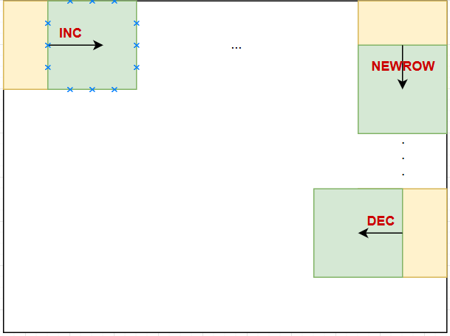

*Figure 3: Algorithm of Address Calculation Block*

There would be four state indicating whether the zigzag movement is in initial, increase, decrease or new row state. Initial state is the state at the first beginning, and the corresponding signal is INIT. Increase state is going to the right, and the corresponding signal is that incdec equals to 1.Decrease state is going to the left, and the corresponding signal is that incdec equals to 0. New row state is going down, and the corresponding signal is that new_row equals to 1. The corresponding upper left corner address would be the output.

**2.3.3. Window Buffer Initialization**

Each pixel is represented by 1 byte. Since by default AHB Lite bus process a word (4 bytes) at a time, the efficient way to read data from the data bus is to read a chunk of 4 bytes (4 pixels) at a time so that there is no redundant byte. In order to minimum the number of data reading, it is necessary to construct a 8x8 window buffer so that after processing each pixel, only the replacement of single row or column is needed for further processing.

During the initialization, the window buffer will load the first 8x8 pixel data at the upper left corner of the image.

**2.3.4. Window Buffer Iteration**

For any further iterations, if the pixel of interest moves to the left or the right and doesn’t exceed the current buffer window, the data don’t need any update. When the pixel of interest and its surrounding pixels exceeds the side bounds of the buffer window. It is only necessary to shift the existing columns of values to the left by 4 bytes and load in a 4x8 set of data. If the pixel of interest moves downward, it behaves in a similar way as explained above.

Instead of starting at the beginning of each row, in order to minimize the amount of data updating, the pixel of interest will move in a zigzagging pattern such that only 32 pixels need to be updated each time except the initialization.

In the corner cases where the remaining of a row is not enough for 4 pixels or the remaining rows is less than 4, The data shift process will react accordingly.

**2.3.5. Gaussian Blur**

For each pixel of interest, Gaussian blur will apply the following kernel to it.

|  |  |  |
| --- | --- | --- |
| **1** | **1** | **1** |
| **1** | **1** | **1** |
| **1** | **1** | **1** |

*Figure 4: Gaussian Blur Kernel*

In such a way, the image gets blurred and only the major edges can be detected by the Sobel filter. Thus, the quality of the edge detection can be improved.

The blurred data will be sent to another buffer for further processing.

**2.3.6. Gaussian Buffer**

The Gaussian Blur module will produce a 6x6 matrix to the second window buffer, this window buffer will be filled with one pixel at a time. And the input also includes the coordination will to put the pixel.

**2.3.7. Sobel Filter Operation**

With the window buffer produced from Gaussian blue. The Sobel filter module apply the following filter kernels on each pixel of the image.

|  |  |  |
| --- | --- | --- |
| **-1** | **0** | **1** |

|  |
| --- |
| **-1** |
| **0** |
| **1** |

*Figure 5: Sobel Filter Kernel*

By applying the filter kernel in both horizontally and vertically, we will be able to find the gradient relation between the pixel of interest and its surrounding pixels in both directions.

**2.3.8. Gradient Computing Operation**

After a group of gradients is found, the Pythagorean theorem is applied to the two gradient vectors. The calculated edge value is only necessary for comparing with the threshold, leave it as a squared value is acceptable.

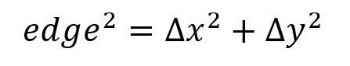

If the edge value is larger than a threshold of our choice, it is recognized as a valid edge and will output FF (i.e. white pixel). Otherwise it will output 00 (i.e. black pixel).

By performing the operation above, an image with only major edges will be generated.

***2.4. Requirements for Design***

The current cell phone camera provides an image quality of about 8 megapixels. With given clock speed restriction, it is expected that the edge detection would finish below one second. With a clock speed of at least 500 MHz, it is a reasonable aim to complete the image processing in less than 1 second. This requires pipeline transfer of data and multitasking. Meaning that all tasks are done parallelly so that ideally no clock cycles are wasted for waiting for new data coming in. The pipelining will be handled by the state machine in the controller module to the greatest extend. The method to buffer 8x8 data matrix is selected so that the less data reading is performed such that no spaces are wasted. Moreover, the zigzagging pattern that the pixel of interest moves forward will also help to reduce the number of data reading.

In terms of area, the image processing requires a large amount of registers to store intermediate values. When implementing the edge detector, the choice of threshold number is critical. The actual choice was tested by a Python Script. Applying the different thresholds of the design will affect the final output rate. If a large threshold is chosen, the output will be vague (the edges of the picture will not be shown clearly, there might be missing parts if the color gradient is not large enough). Otherwise, if the threshold is low, the output will be messy (the edge will include redundant edges, which will not perfectly outline the image). Thus, we have to find the perfect threshold of the jpg edge detector through different tests, which is also the first requirement of our design. We used pipelining for our design. And the 800*600 image is produced with in 16 ms.

**3. Design Implementation**

***3.1. Design Architecture***

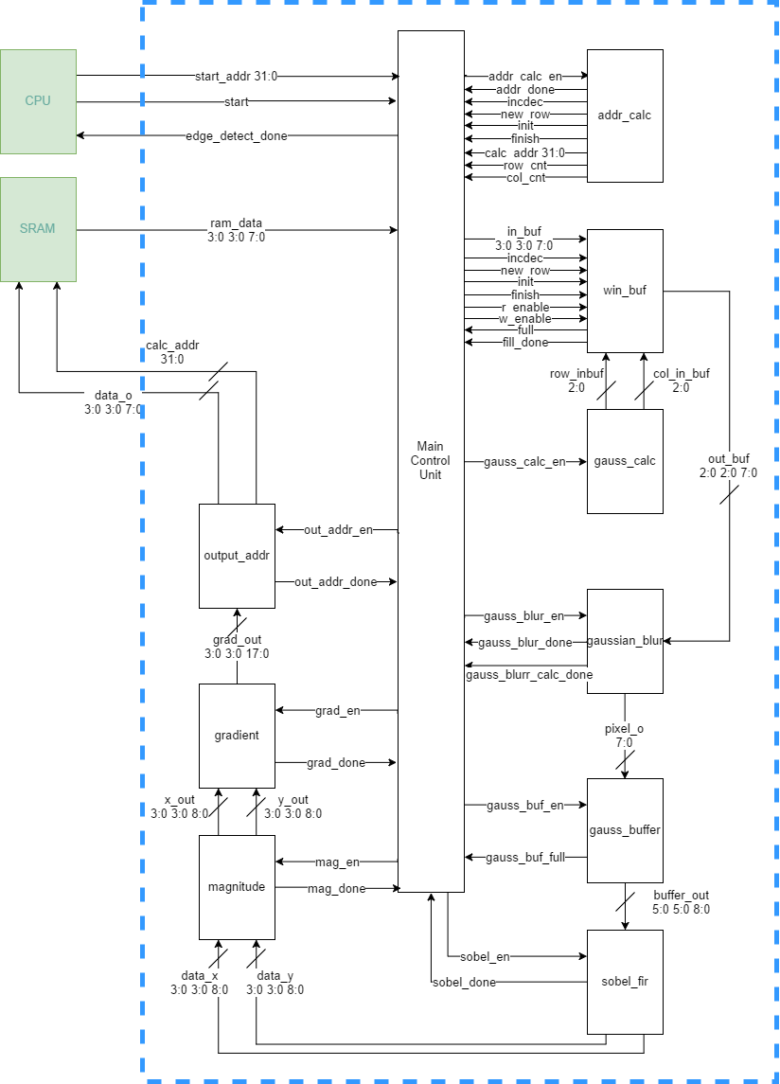

*Figure 6: Edge Detection Architecture Diagram*

The intended implementation architecture is depicted above in Figure 2. A module handling the

implementation of the AHB Lite interface is used to bridge between the external SoC environment and the internal data and status locations. The control unit will be used to control the pipeline transfer of the design. There will be two window buffers for storing the intermediate processing data, one is for storing the original data, the other is for storing the preprocessed data coming from the Gaussian Blur module. The Sobel Filter and Gradient module will serve all the core functions for the edge detector. There are no other storage devices except for the intermediate processed data. The algorithm will be controlled by a Finite-State-Machine with state counters for tracking the progression through the needed stages and handle the data transfer between modules with pipeline transfer feature.

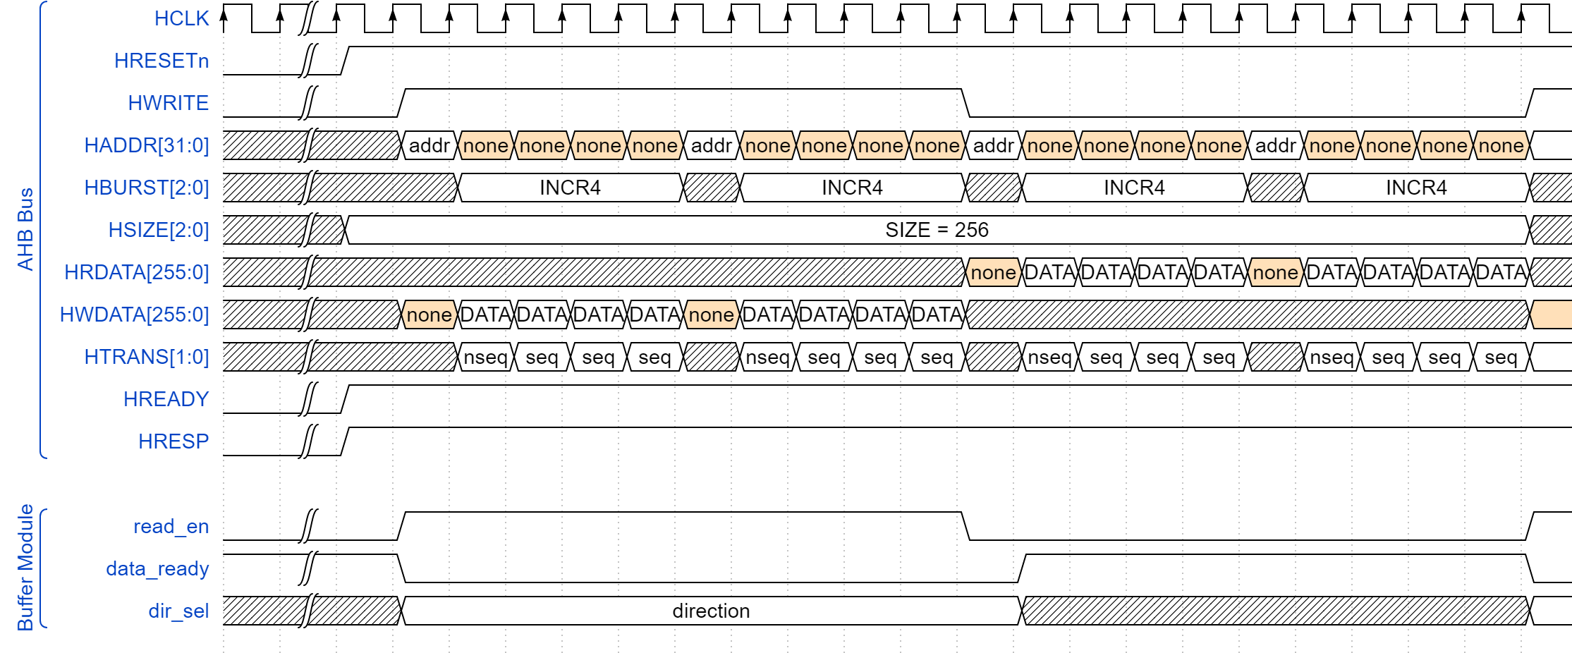

*Figure 7: Edge Detection Timing Diagram*

The timing diagram shows the internal relationship between each blocks. The read enable signal on the original buffer going high indicates that the buffer is loading. While the read enable goes to 0, it means that shifting is done and the shift_done flag gives a strobe to the next block, which is Gaussian block, to make it start doing the corresponding work. While the Gaussian block finishes the shifting and calculation, it sets the shift_done signal to high and stores the value into the blurred buffer. When all data from Gaussian block was transmitted, the shift_done in the blurred buffer sets to high to make the sobel block start working. Finally, when the sobel block finishes working, it shifts out the final output to the Gradient block, which is a purely combinational block.

|  |  |  |  |  |
| --- | --- | --- | --- | --- |
| **Core Area Calculations** | | | | |
| **Name of Block** | **Category** | **Gate/FF Count** | **Area (um2)** | **Comments** |
| Window Buffer | Reg. w/ Reset | 1536 | 3,686,400 | 8x8x24x1600x1.5 |
| Gaussian Buffer | Reg. w/ Reset | 864 | 2,073,600 | 6x6x24x1600x1.5 |
| Gaussian Blur | Combinational | 446 | 334,500 | 8*24*2(adder)+3*4(counter)+(2+3)*10*3(divider) |
| Sobel Filter | Combinational | 2496 | 1,872,000 | 2 * 3*(8 bit substractor, 8 FA + 10 XOR gates) for X , Y calculation, totally 16 pixels |
| Gradient Calculation | Combinational | 384 | 288,000 | x^2+y^2 |
| Total Core Area |  |  | 8,254,500 |  |
| **Chip Area Calculations (units in um or um2)** | | | | |
| Number of I/O Pads: | 12 | | |  |
| I/O Pad Dimensions: | 90 | by | 300 |  |
| I/O Based Padframe Dimensions: | 870 | by | 870 |  |
| Core Dimensions | 2873 | by | 2873 |  |
| Core Based Padframe Dimensions: | 3773 | by | 3773 |  |
| Final Padframe Dimensions: | 3773 | by | 3773 |  |
| Final Chip Area: | 14,236,016 | | |  |

*Table 4: Design Budgeting estimation*

***3.2 Functional Block Diagram***

**3.2.1 Addres Calculation Module**

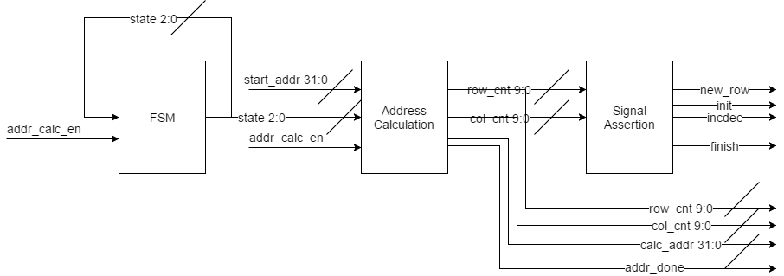

*Figure 8: addr_calc module block diagram*

The address calculation module is used for interaction between out design and the system that is connected to our design. This module will calculate the address for data read from SRAM and handle multiple principle system signals. Once the module is enabled, it’s internal column counter will start to increase with a step of 4 (After the first iteration, it is increased by 8). Once the column count reaches the end of a row (792), the row counter will increase by a step of 4 (After the iteration of the first row, it is increased by 8). One single increment of column counter is considered a addr_done event. The corresponding signal will be asserted and the current address will be passed out. The start_addr signal is passed in to the module as the start address for the convenience of calculation. init indicates whether the current iteration is the first iteration. incdec indicates whether the buffer is going right or left. new_row is asserted when the iteration encounters an edge of the image. finish signal is asserted only when the entire image processing is done.

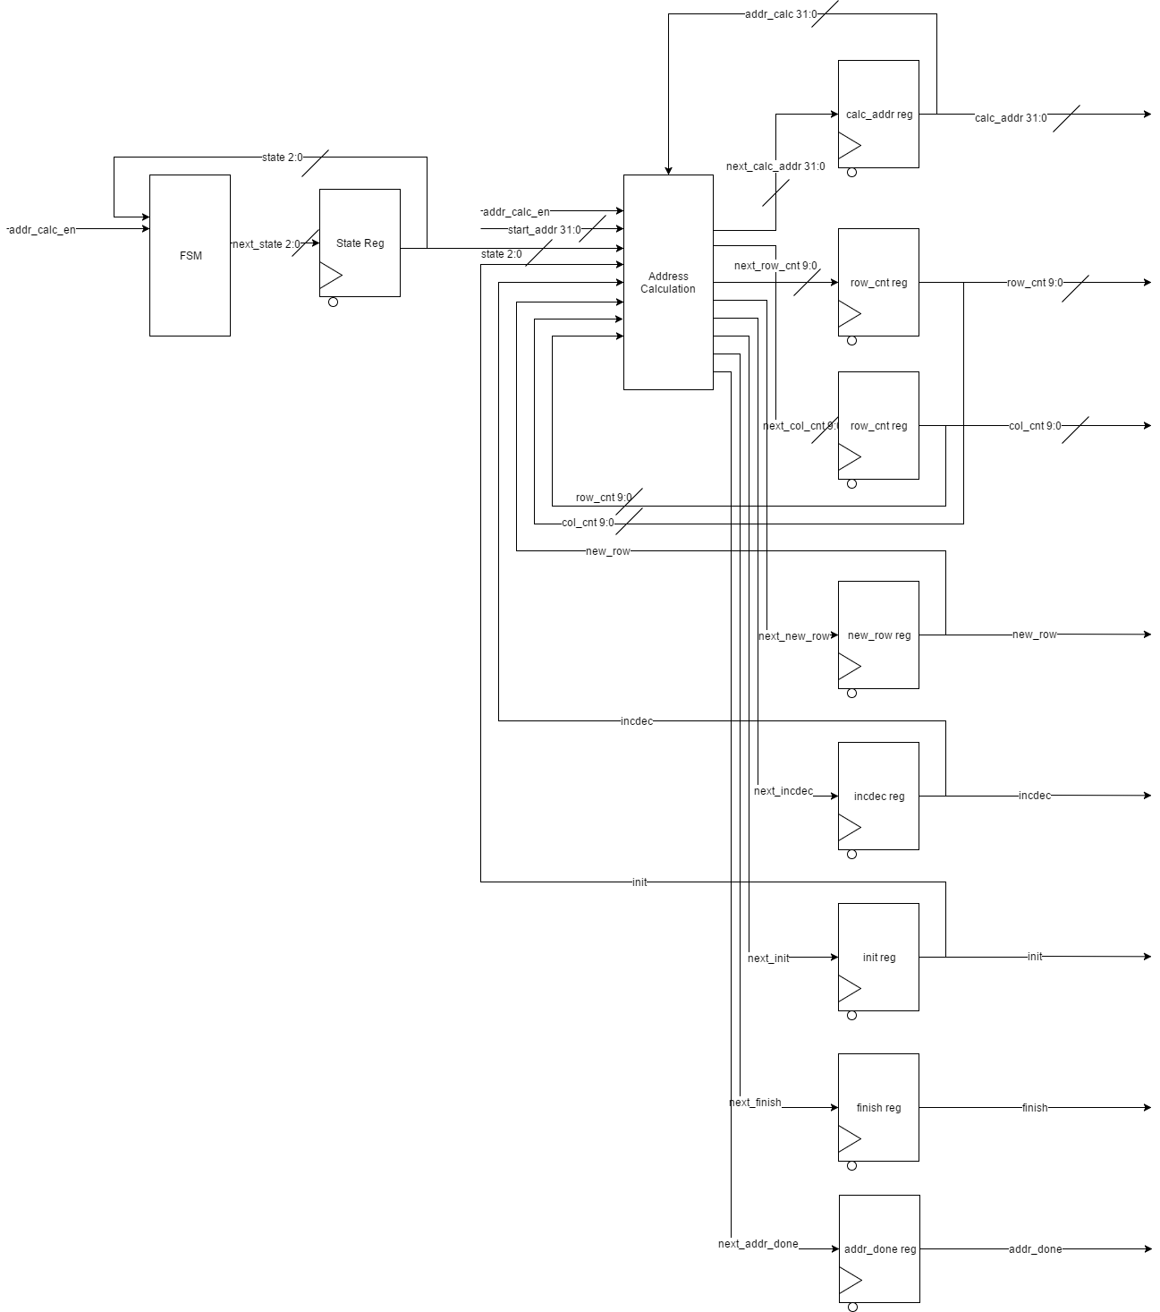

*Figure 9: addr_calc module RTL*

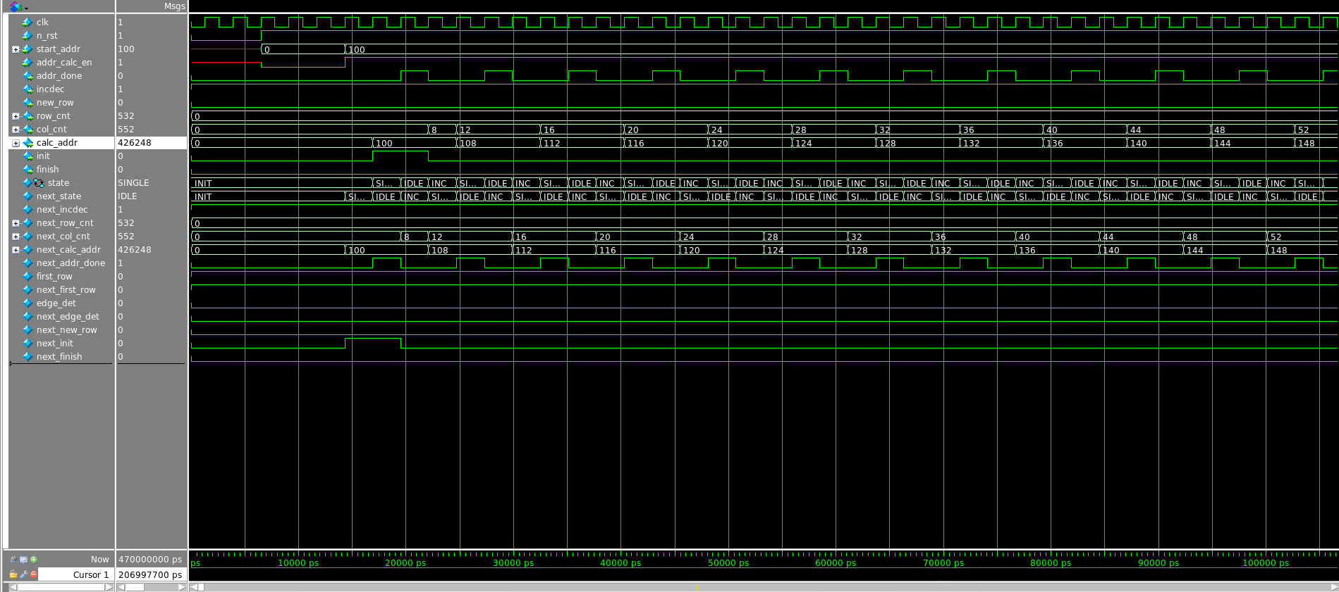

*Figure 10: addr_calc module start and middle waveform*

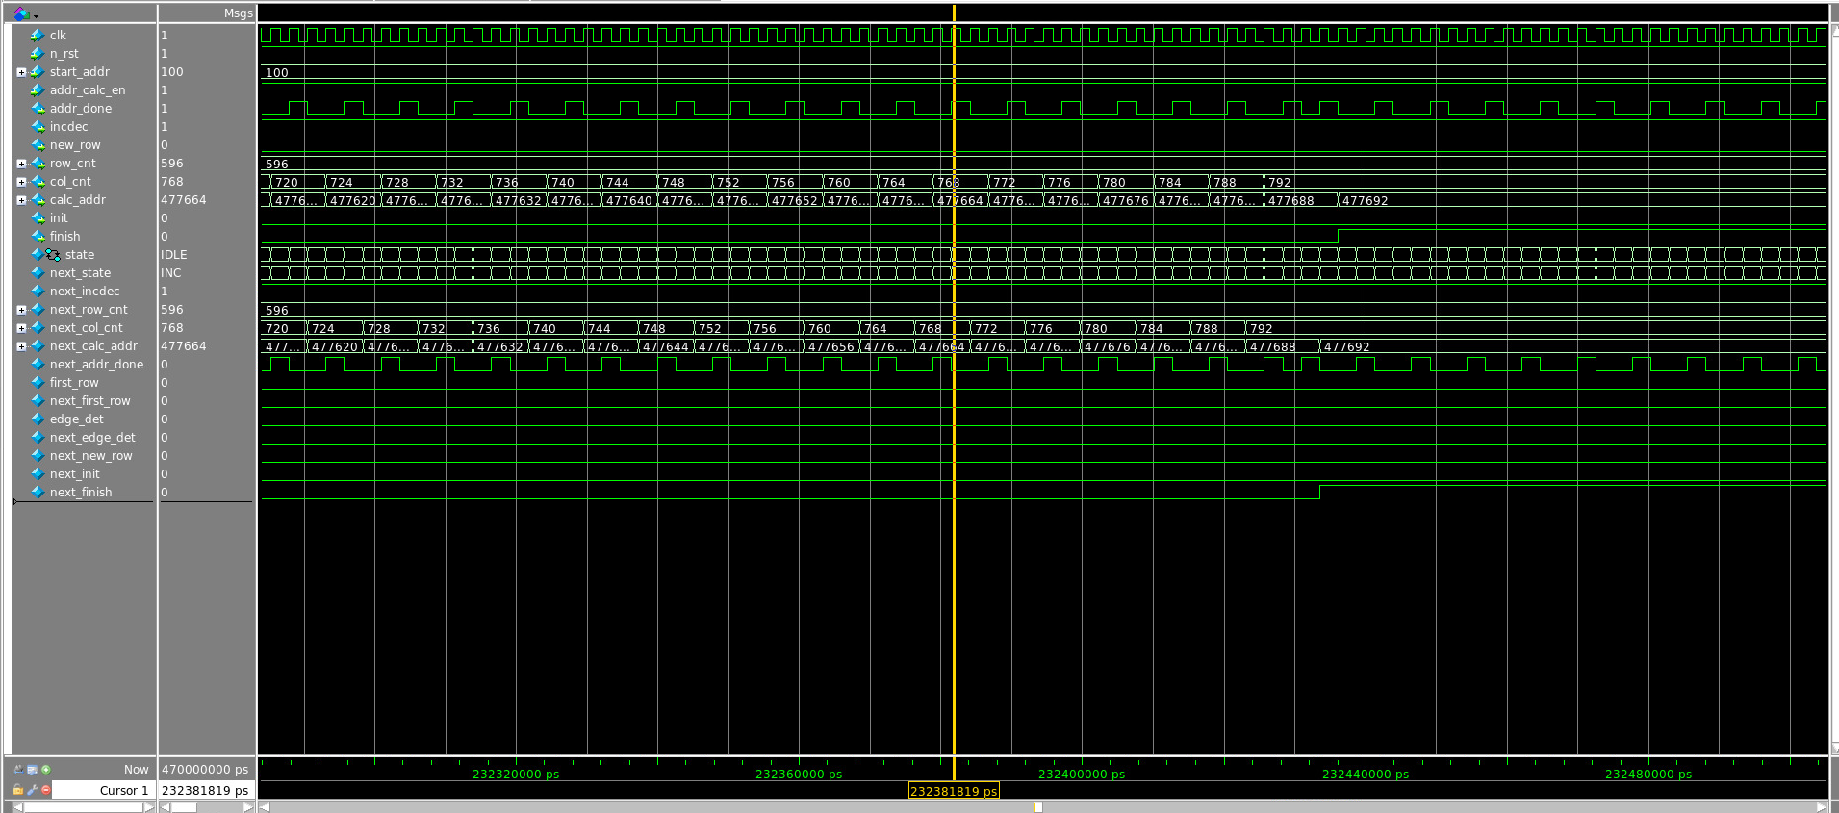

*Figure 11: addr_calc module finishing waveform*

|  |  |  |
| --- | --- | --- |
| Components | Count | Area (um^2) |
| Normal Gates | 10 | 10*8*50*500 = 2000000 |
| mux | 10 | 4 * 32 * 500 = 64000 |
| flipflops | 32+10+10+4 = 56 | 56*1600 = 89600 |
| Total | 2153600 (um^2) | |

Rationale: There are totally 56 flip-flops in this module. By the estimation of 1600 um^2 per filp-flop. Also, there are no normal gates in this module. There are 10 multiplexes, each mux requires 40 normal gates and each gate is 500 um^2. By combining these together, we get the total approximate area is 2153600 um^2.

Estimated area versus actual area discussion: The actual area, based on the report, is 253386 um^2. The difference might be from the area of wires.

**3.2.2 Window Buffer Module**

The window buffer module is used for storing intermediate data from the SRAM for further calculation. The behavior of window buffer will be determined by the signals handled by the previous addr_calc module. This win_buf module consist of a large number of registers and a shift register. The shift register is for handling the preservation of existing data so that the number of data read can be minimized. Based on incdec, new_row signals calculated by addr_calc, the shift register will shift the existing data in the buffer to the correct position. If incdec is asserted, the shift register will shift to the left and clear the spaces on the right half for new data. If incdec is negated, the shift register will shift data to the right and clear the spaces on the left half for new data. If new_row is asserted, the shift register will shift data upward and clear up spaces for new data coming into the lower half of the buffer. After the shifting operation. The window buffer will start to fill in new data. One word at a time. Once a single fill is done. The fill_done signal will be asserted so that a new address can be calculated. Once the whole buffer is full, the full signal will be asserted to enable later modules.

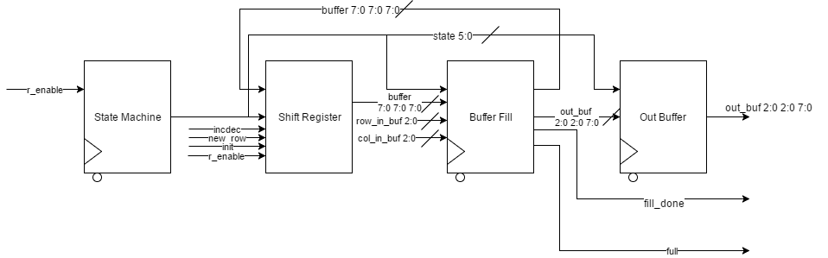

*Figure 12: win_buf module block diagram*

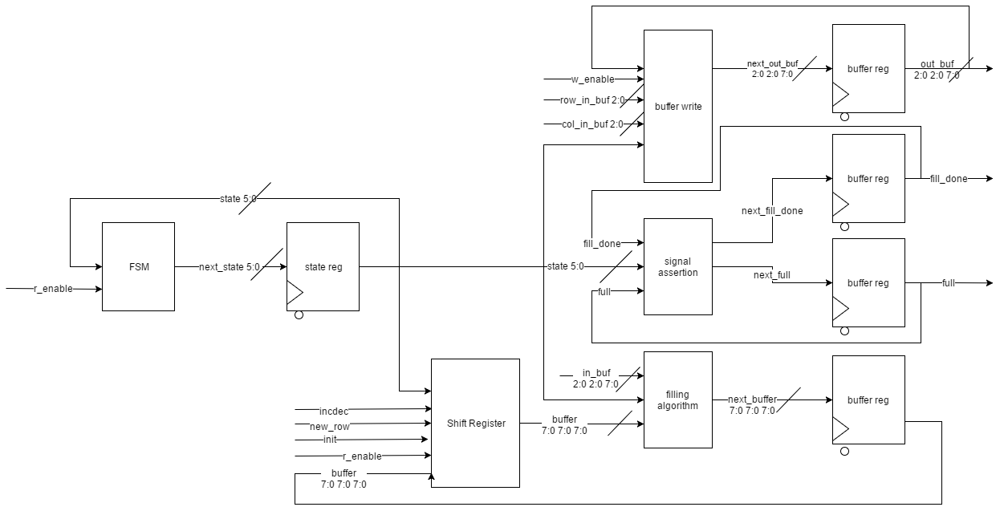

*Figure 13: win_buf module RTL*

As mentioned above, the filling process is performed one word at a time. Thus the buffer is divided into 16 sections. If init is asserted, the buffer will fill 1 through 16. If incdec is asserted, the buffer will fill 9 through 16. If incdec is negated, the buffer will fill 1 through 8. If new_row is asserted, the buffer will fill 5 through 8 and 13 through 16.

|  |  |
| --- | --- |
| 1 | 9 |
| 2 | 10 |
| 3 | 11 |
| 4 | 12 |
| 5 | 13 |
| 6 | 14 |
| 7 | 15 |
| 8 | 16 |

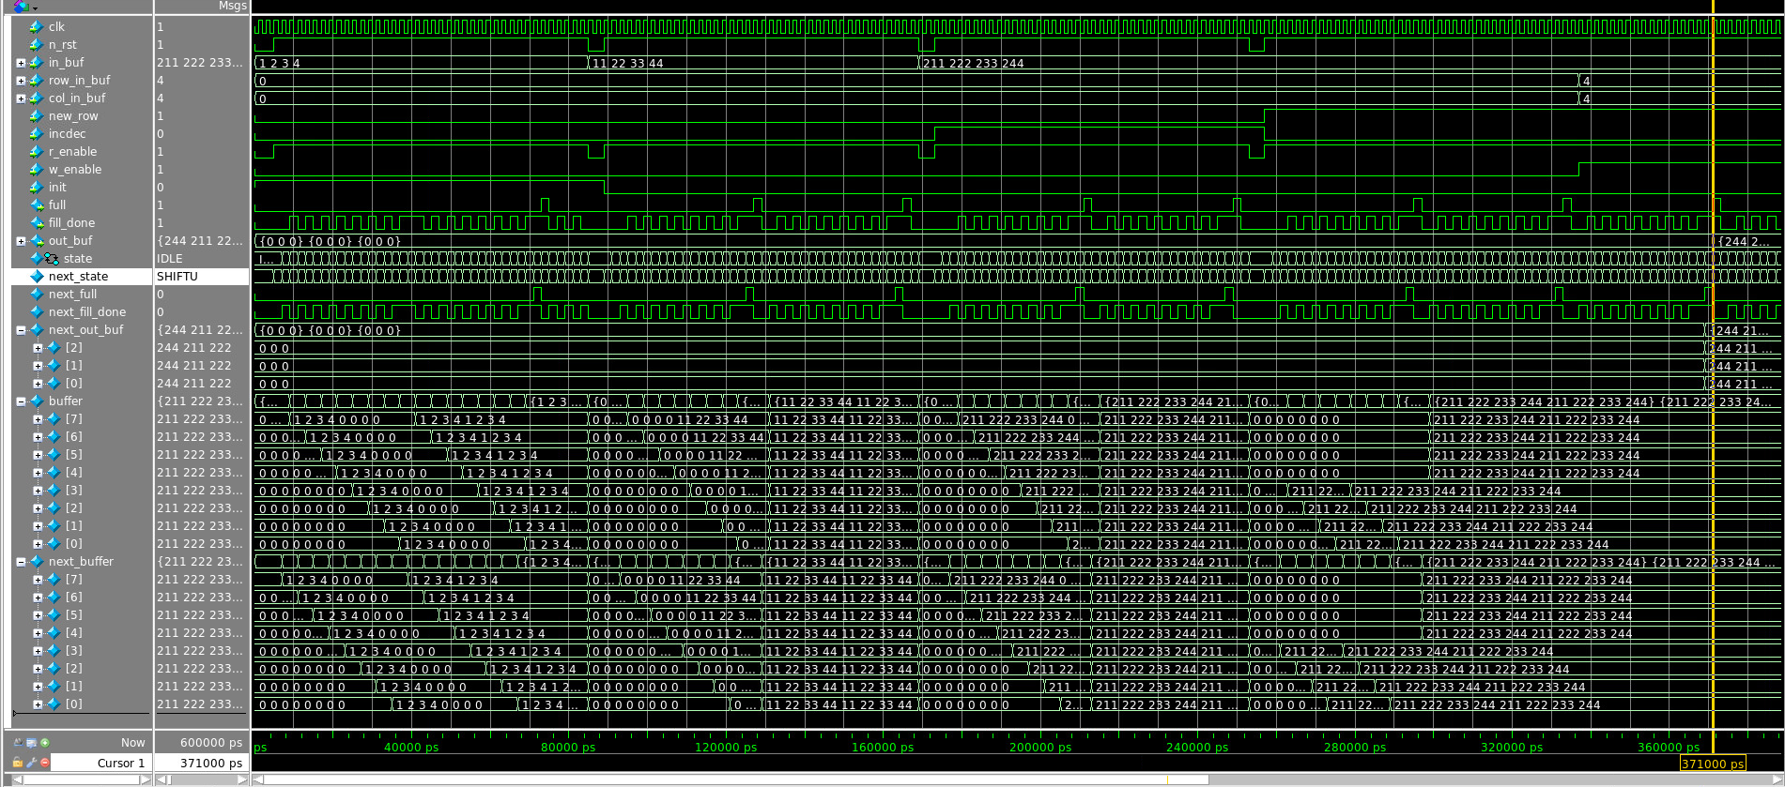

*Figure 14:win_buf module operation waveform*

|  |  |  |
| --- | --- | --- |
| Components | Count | Area (um^2) |
| Normal Gates | 0 | 0 |
| mux | 3 | 4 * 3 * 500 = 6000 |
| flipflops | 8*8*8 + 3*3*8 + 6 = 590 | 590*1600 = 944000 |
| Total | 950000 (um^2) | |

*Table 5: win_buff area estimation*

Rationale: There are totally 590 flip-flops in this module. By the estimation of 1600 um^2 per filp-flop. Also, there are no normal gates in this module. There are 3 multiplexes, each mux requires 4 normal gates and each gate is 500 um^2. By combining these together, we get the total approximate area is 950000 um^2.

Estimated area versus actual area discussion: The actual area, based on the report, is 2042820 um^2. The difference might be from the area of wires.

**3.2.3 Gaussian Blur Module**

**Gaussian_addr_calc**

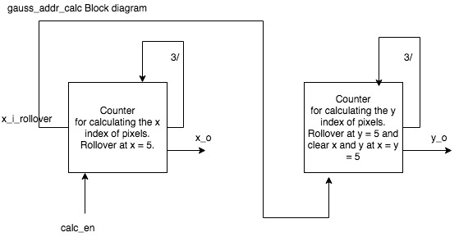

*Figure 15: Block Diagram of Gaussian Address Calculation Block*

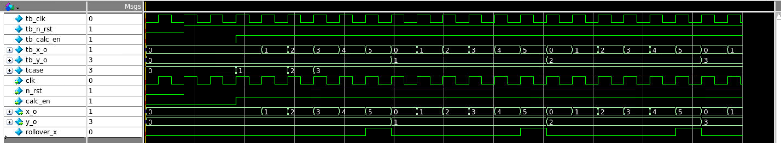

*Figure 16: Waveform Diagram of Gaussian Address Calculation Block*

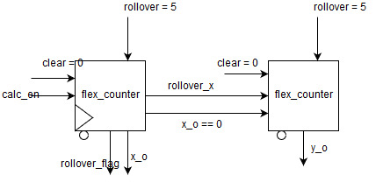

*Figure 17: RTL Diagram of Gaussian Address Calculation Block*

**Gaussian_blur**

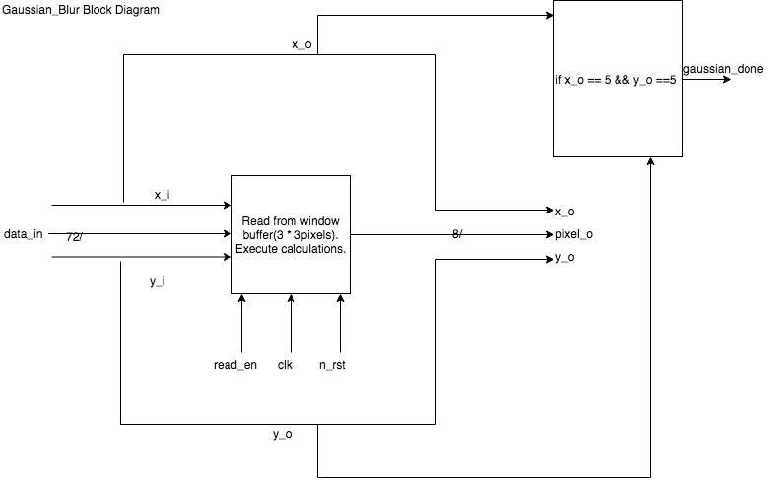

*Figure 18: Block Diagram of Gaussian Blur Block*

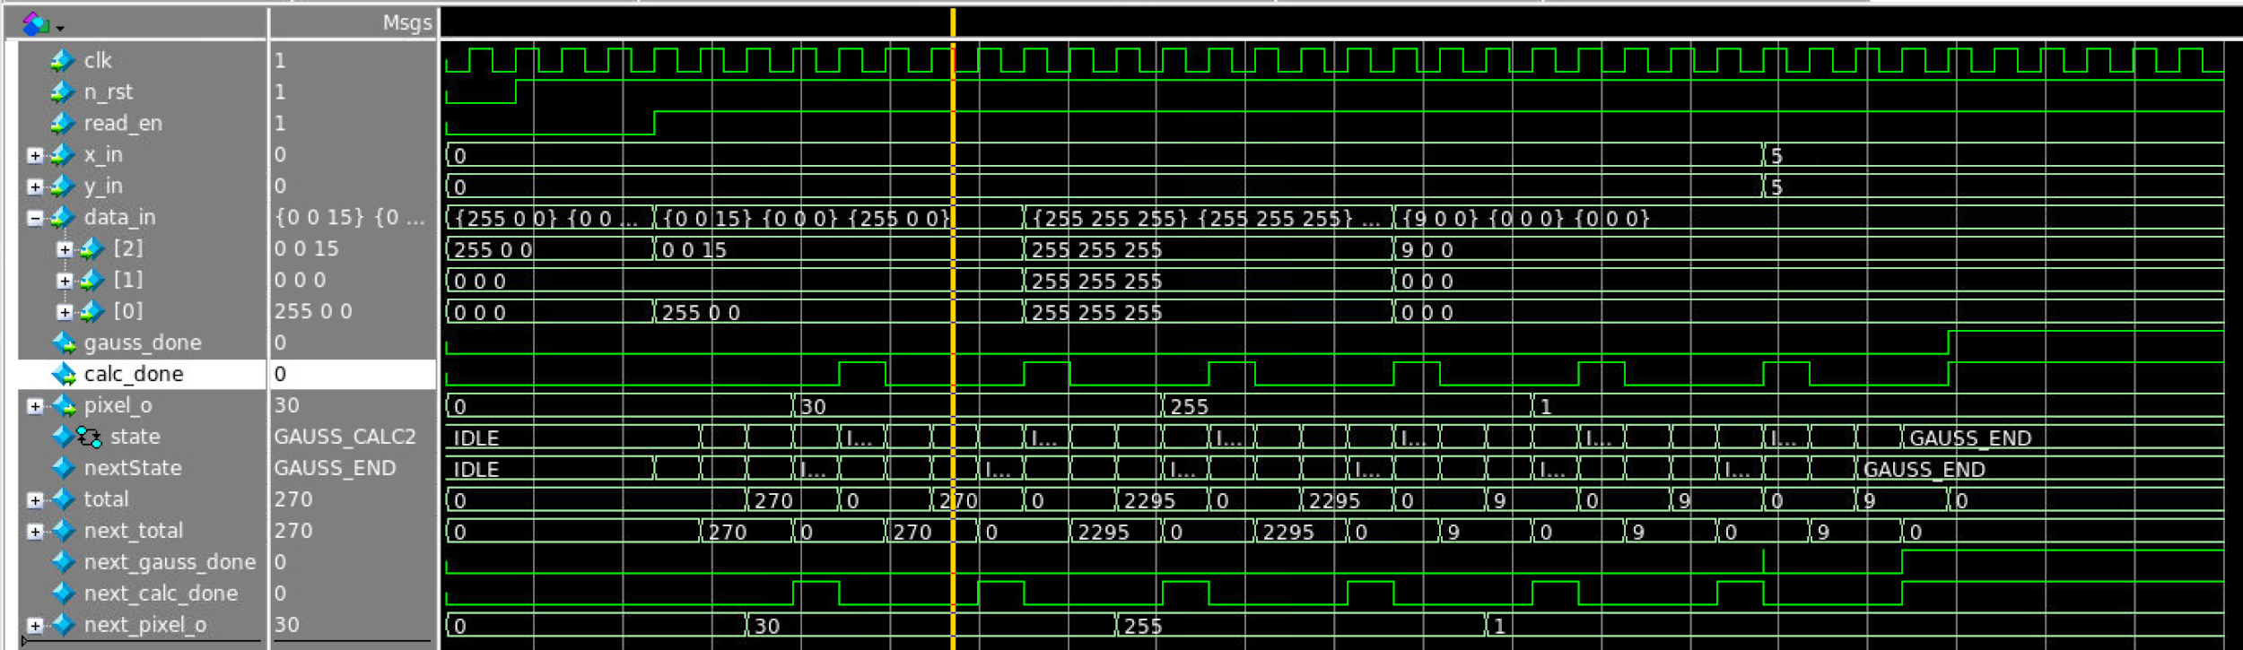

*Figure 19: Waveform Diagram of Gaussian Blur Block*

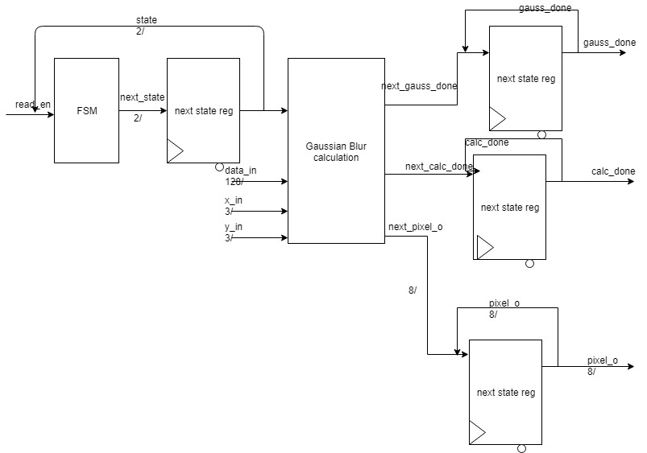

*Figure 20: RTL Diagram of Gaussian Blur Block*

**Gauss_buffer**

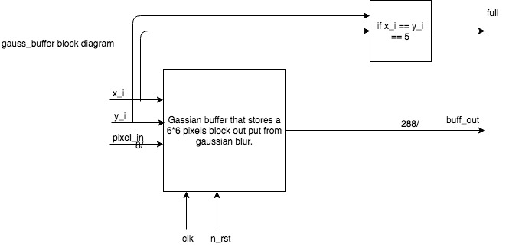

*Figure 21: Block Diagram of Gaussian Buffer Block*

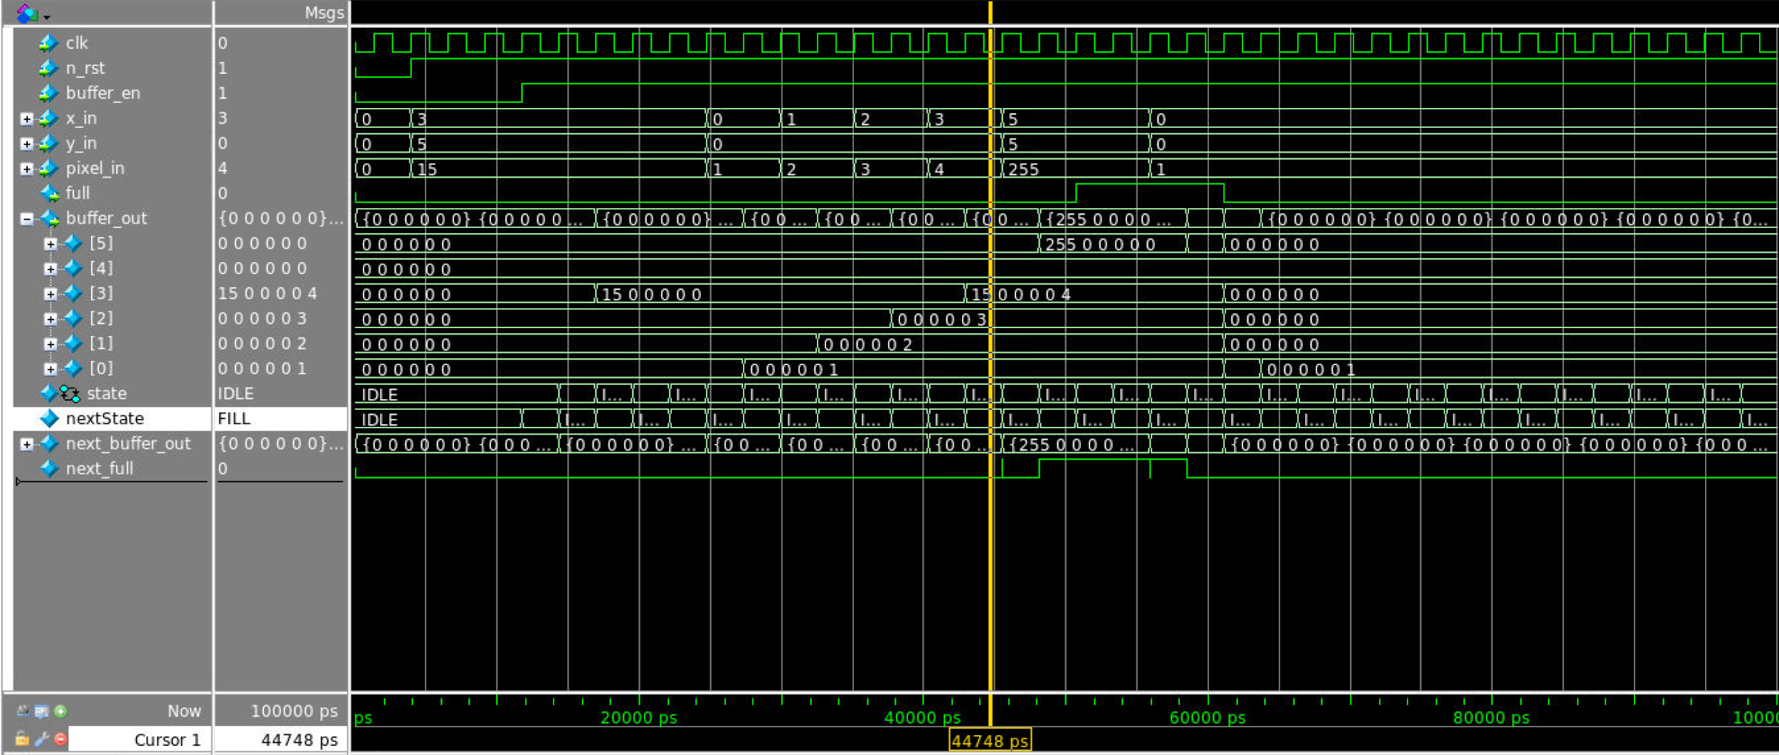

*Figure 22: Waveform Diagram of Gaussian Buffer Block*

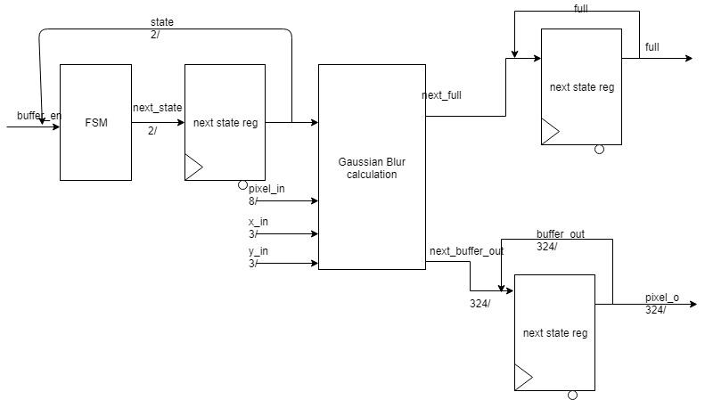

*Figure 22: RTL Diagram of Gaussian Buffer Block*

The Gaussian Blur module have totally three functional blocks. The first block is gauss_addr_calc that will calculate the relative x, y coordinates for win_buf and gauss_buffer. The second block is guassian_blur block. This block will do the algorithm part. It will take the 3*3 pixel data in win_buf at the given coordinates and then output the average of the 9 pixels. If the input x and y coordinates both reaches 5, it will output a gaussian_done signal to tell the system to fill in the win_buf. The third block is gauss_buffer that will store the outputs from gaussian_blur. It will store 6*6 pixels and when the buffer is full (x and y coordinates both reaches 5), it will output a full signal and the 6*6 pixel to next block(sobel).

Area Estimation:

**guass_addr_calc**

|  |  |  |
| --- | --- | --- |
| Components | Count | Area (um^2) |
| Normal Gates | 15 | 15*500 = 7500 |
| flipflops | 12 | 12*1600 = 19200 |
| Total | 26700 (um^2) | |

*Table 6: gauss_addr_calc area estimation*

Rationale: There are totally 12 flip-flops in this module. By the estimation of 1600 um^2 per filp-flop. Also, there are approximately 12 normal gates which is approximately 19200 um^2. By combining these two together, we get the total approximate area is 26700 um^2.

Estimated area versus actual area discussion: The actual area, based on the report, is 28926 um^2. The difference might be from the area of wires.

**gaussian_blur**

|  |  |  |
| --- | --- | --- |
| Components | Count | Area (um^2) |
| Normal Gates | 9 | 9*8*50*500 = 1800000 |
| flipflops | 12 | 12*1600 = 19200 |
| Total | 199200 (um^2) | |

*Table 7: guassian_blur area estimation*

Rationale: There are totally 12 flip-flops in this module. By the estimation of 1600 um^2 per filp-flop, there are totally 19200 um^2 for flip-flops. Also, there are approximately 9 normal gates which is approximately 1800000 um^2. By combining these two together, we get the total approximate area is 199200 um^2.

Estimated area versus actual area discussion: The actual area, based on the report, is 201222 um^2. The difference might be from the area of wires.

**gauss_buffer**

|  |  |  |
| --- | --- | --- |
| Components | Count | Area (um^2) |
| flipflops | 327 | 327*1600 = 523200 |
| Total | 523200 (um^2) | |

*Table 8: gauss_buffer area estimation*

Rationale: There are totally 327 flip-flops in this module. By the estimation of 1600 um^2 per filp-flop, there are totally 523200 um^2 for flip-flops. We get the total approximate area is 523200 um^2.

Estimated area versus actual area discussion: The actual area, based on the report, is 619893 um^2. The difference might be from the area of wires.

**3.2.4 Sobel Filter Module**

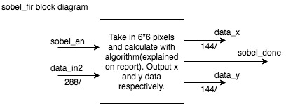

*Figure 23: Block Diagram of Sobel Filter Block*

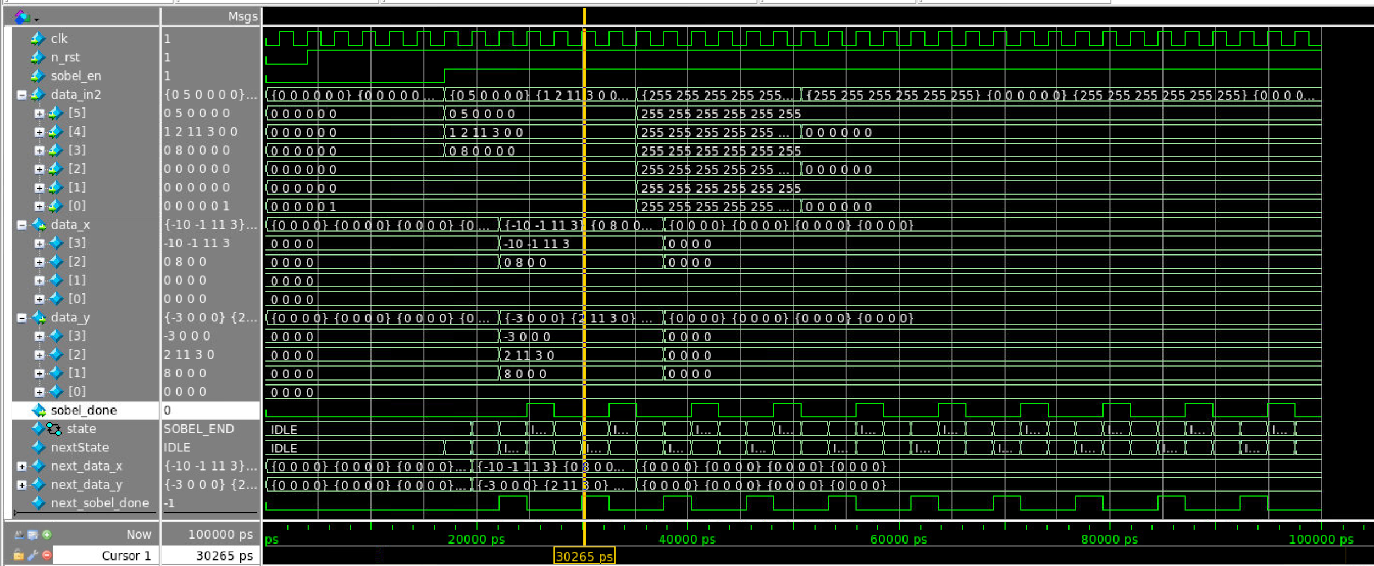

*Figure 24: Waveform Diagram of Sobel Filter Block*

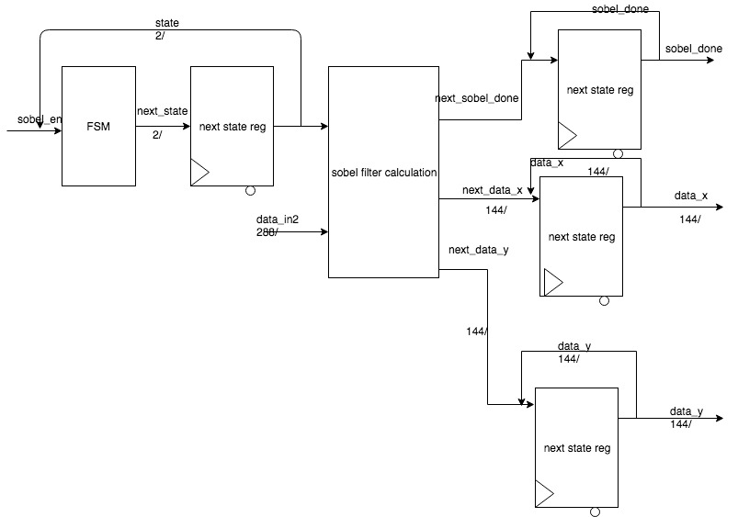

*Figure 25: RTL Diagram of Sobel Filter Block*

The sobel filter module will firstly detect if the soble_en is assert. If the sobel_en is asserted, the block will start process. It will take in the buffer outputs and do the calculation(explained previously). and output the corresponding x and y data. If the whole calculation finishes, the sobel_done signal will be asserted.

Area Estimation:

|  |  |  |
| --- | --- | --- |
| Components | Count | Area (um^2) |
| Normal Gates | 900 | 900*500 = 450000 |
| flipflops | 291 | 291*1600 = 465600 |
| Total | 915600 (um^2) | |

*Table 9: sobel_fir area estimation*

Rationale: There are totally 291 flip-flops in this module. By the estimation of 1600 um^2 per filp-flop, there are totally 465600 um^2 for flip-flops. Also, there are approximately 900 normal gates which is approximately 450000 um^2. By combining these two together, we get the total approximate area is 915600 um^2.

Estimated area versus actual area discussion: The actual area, based on the report, is 979812 um^2. The difference might be from the area of wires.

**3.2.5 Magnitude and gradient module**

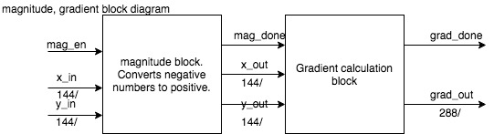

*Figure 26: Block Diagram of Magnitude and Gradient Calculation Block*

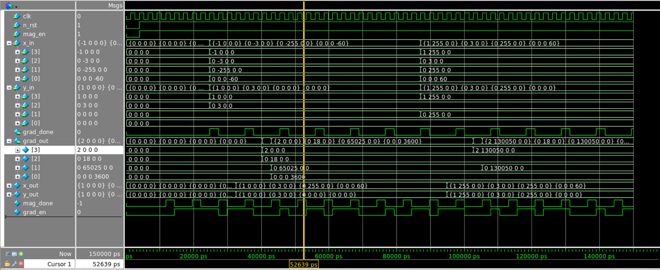

*Figure 27: Waveform Diagram of Magnitude and Gradient Calculation Block*

The magnitude and gradient block are combined together. Firstly it will detect if the mag_en is asserted. If it is asserted, the block will start processing. The magnitude block will take in and x and y data output from sobel filter and convert the negative value into positive and give the data to gradient to do calculation(explained previously). After the whole process finishes, the block will output a grad_done signal to denote that the process is done and grad_out to denote which pixel should be printed or not.

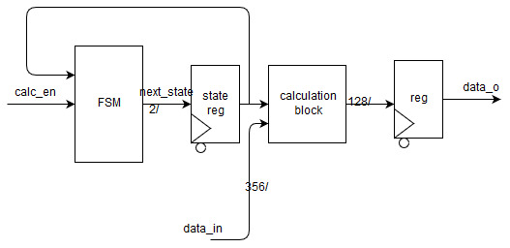

*Figure 28: RTL Diagram of Magnitude and Gradient Calculation Block*

|  |  |  |
| --- | --- | --- |
| Components | Count | Area (um^2) |
| Mux | 32 + 0 | 4*32*500 = 64000 |
| Normal Gates | 1080 + 2672 | (1080+2672)*500 = 1876000 |
| flipflops | 165 + 165 | 165*2*1600 = 528000 |
| Total | 2468000 (um^2) | |

*Table 10: magnitude and gradient area estimation*

Rationale: There are 32 multiplexer for the 2 4x4 matrix, each mux requires 4 normal gates and each gate is 500 um^2. There are 16 full adder with 10-bit wide, 32 full adder with 9-bit wide,each bit requires 5 gates, 32 8-bit multiplier, each multiplier require 56 gates and each gate is 500 um^2. From the source code, we can see that we need 330 flipflops, and each flipflop has the area of 1600 um^2.

Estimated area versus actual area discussion: The actual area, based on the report, is 2559051 um^2. The difference might be from the area of wires.

**3.2.6 output address block**

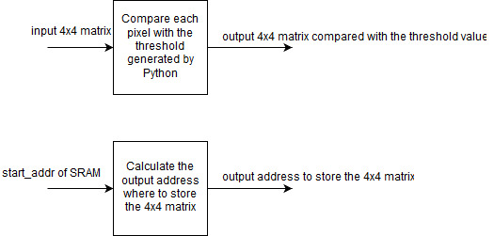

*Figure 29: Block Diagram of Output Address Block*

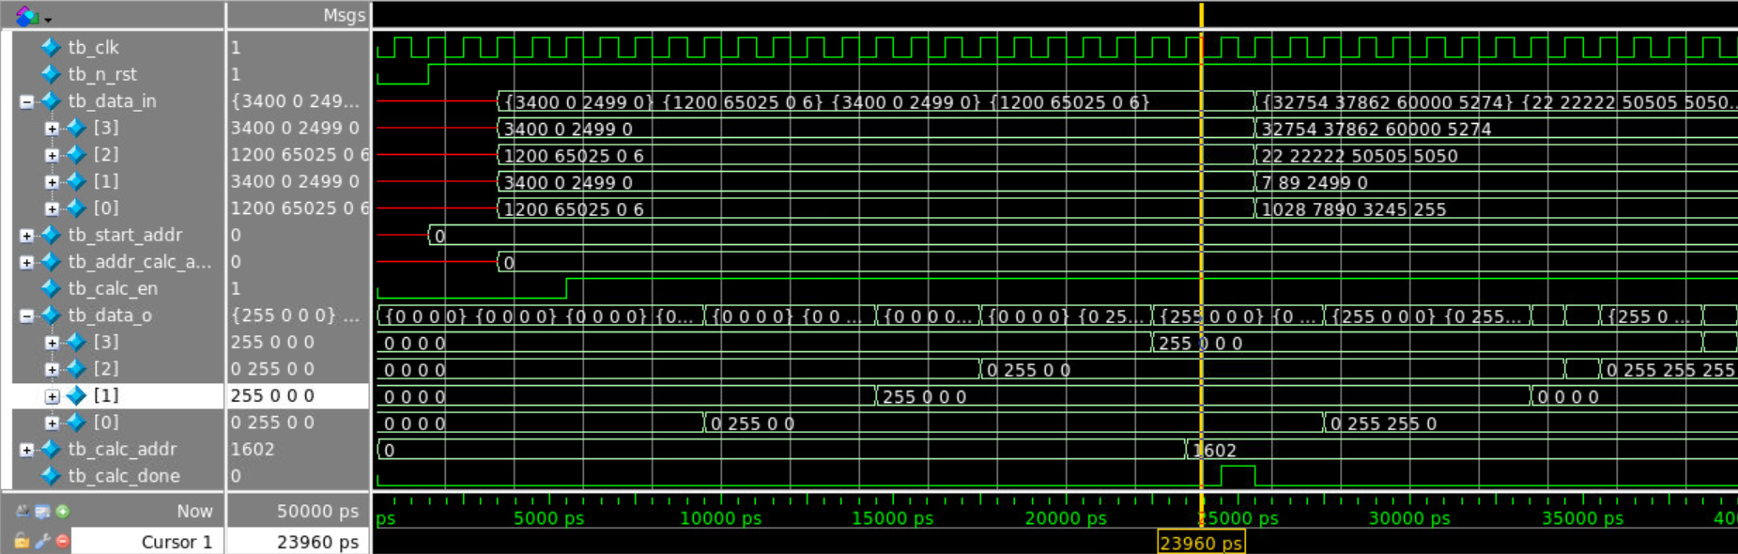

*Figure 30: Waveform Diagram of Output Address Block*

This block does two things, one is to output the corresponding value after comparing it to the threshold value (2500), and the other one is to generate the output address based on the address calculated by the address calculation block. Within the block, several states are used and each one is used to compare one pixel with threshold value. If the pixel value is greater the threshold, 255 is given (white), and 0 (black) otherwise. The last state is to calculate the output address, which is the input address added by 1602. Because for a 8x8 matrix, we want to calculate the address of the upper left corner of the middle 4x4 matrix. So two rows should be added (2*800), and 2 other pixels should be added to.

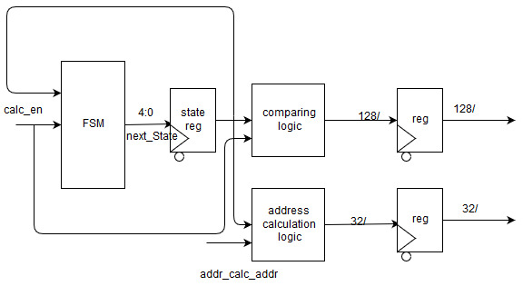

*Figure 31: RTL Diagram of Output Address Block*

|  |  |  |
| --- | --- | --- |
| Components | Count | Area (um^2) |
| Mux | 16 | 4*16*500 = 32000 |
| Normal Gates | 160 | 5*32*500 = 80000 |
| flipflops | 166 | 166*1600 = 265600 |
| Total | 457600 (um^2) | |

*Table 11: output address area estimation*

Rationale: There are 16 multiplexer for 16 pixels, each mux requires 4 normal gates and each gate is 500 um^2. There is one full adder with 32-bit wide, each bit requires 5 gates and each gate is 500 um^2. From the source code, we can see that we need 166 flipflops, and each flipflop has the area of 1600 um^2.

Estimated area versus actual area discussion: The actual area, based on the report, is 527634 um^2. The difference might be from the area of wires.

**3.3 Design Timing Analysis**

Estimate:

|  |  |  |  |  |  |  |  |
| --- | --- | --- | --- | --- | --- | --- | --- |
| **Starting Component** | **Propagation Delay (ns)** | **Combinational Logic** | **Propagation Delay (ns)** | **Ending Component** | **Setup Time or Propagation Delay (ns)** | **Total Path Delay (ns)** | **Target Clock Period (ns)** |
| Gaussian Blur | 0 | Gaussian Blur | 8.9 | Gaussian Buffer | 0.8 | 9 | 2 |
| Sobel Filter | 0 | Sobel Filter | 0.16 | Gradiant Calculation | 0 | 0.16 | 2 |
| Gradiant Calculation | 0 | Gradiant Calculation | 0.13 | - | 0 | 0.13 | 2 |
| WindowBuffer | 0 | - | 0 | Gaussian Blur | 0 | 0 | 2 |
| Gaussian Buffer | 0 | - | 0 | Sobel Filter | 0 | 0 | 2 |

*Table 12: Design timing analysis estimation*

**Rationale:**

There are approximate 45 normal gates between Gaussian Blur and Gaussian Buffer, which will result in a propagation Delay of 8.9 ns. For Sobel Filter to Gradient Calculation, there is only propagation delay and no normal gate in between.

*Figure 32: Timing Report for Edge Detector*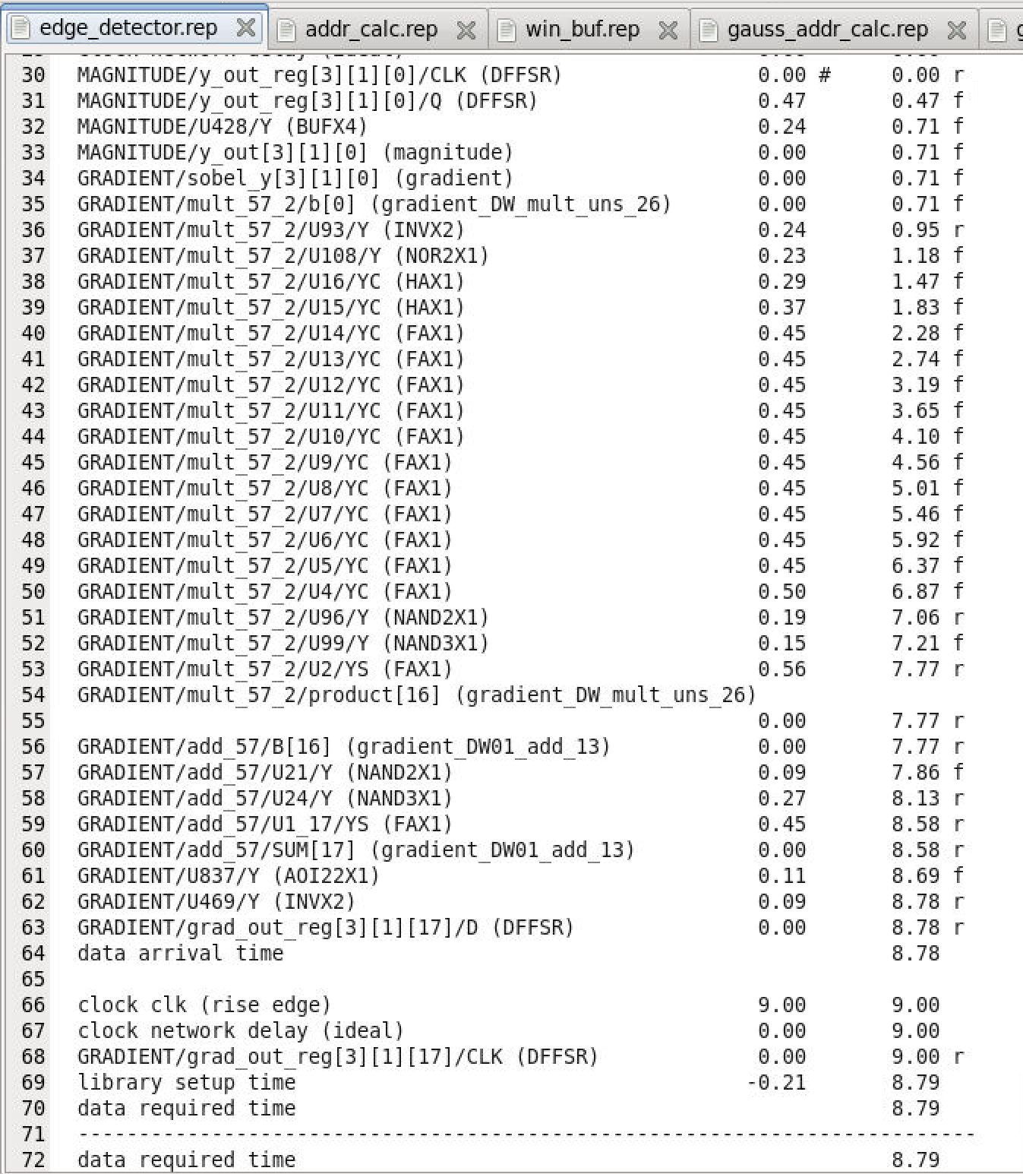

*Figure 33: Timing Report for window buffer block*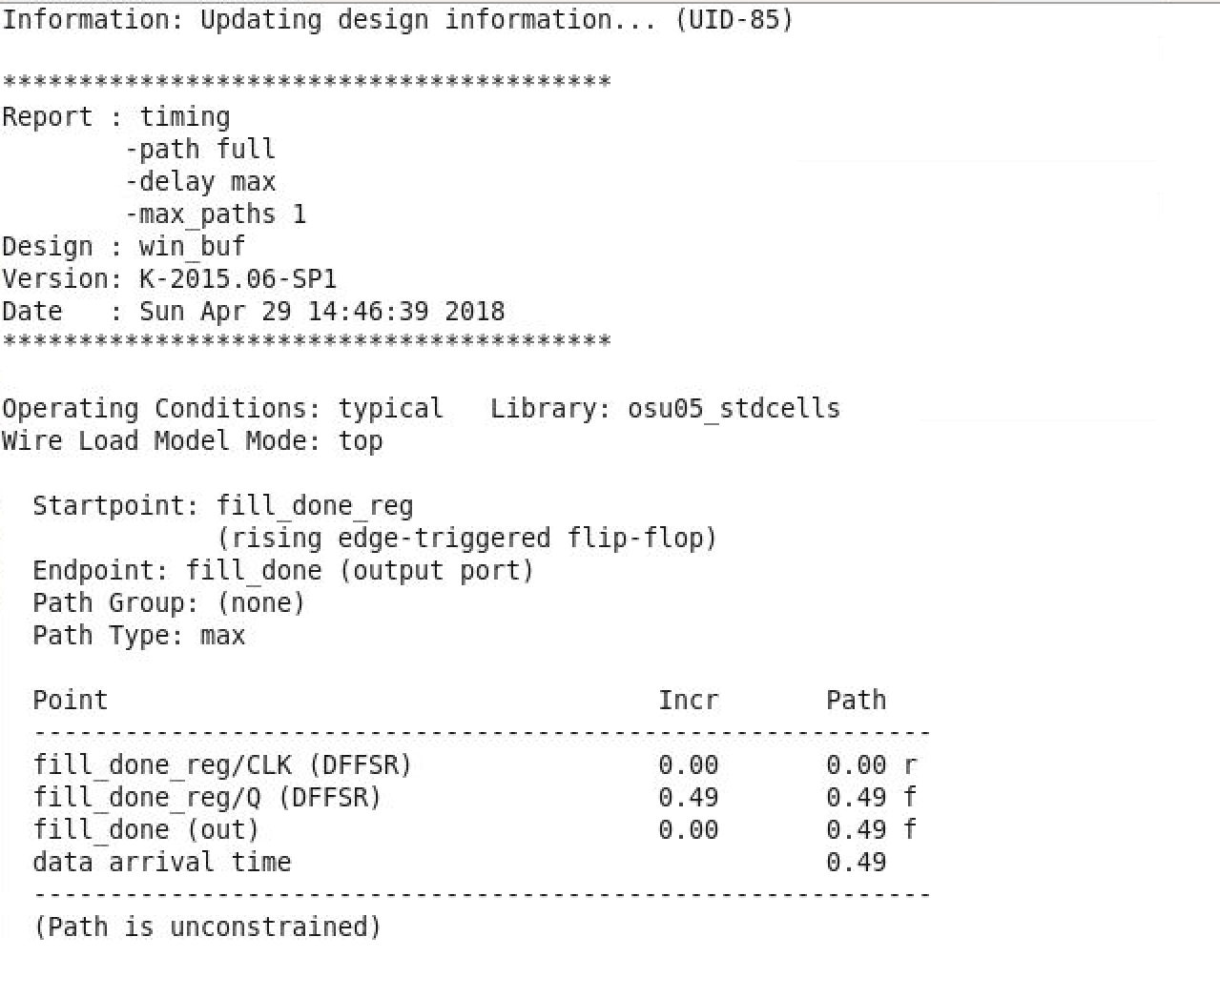

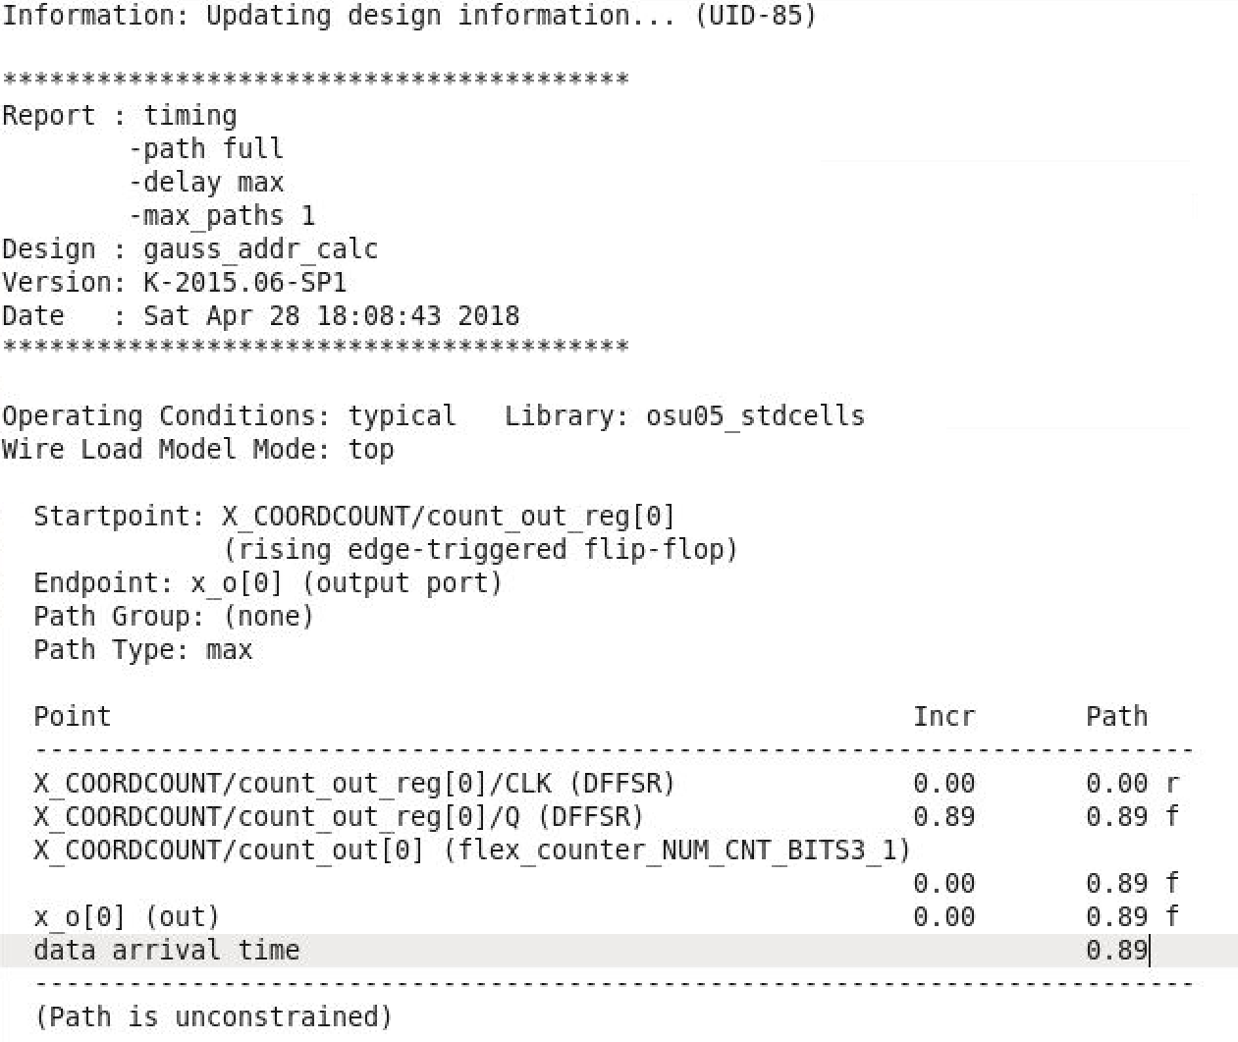

*Figure 34: Timing Report for Gaussian Calculation*

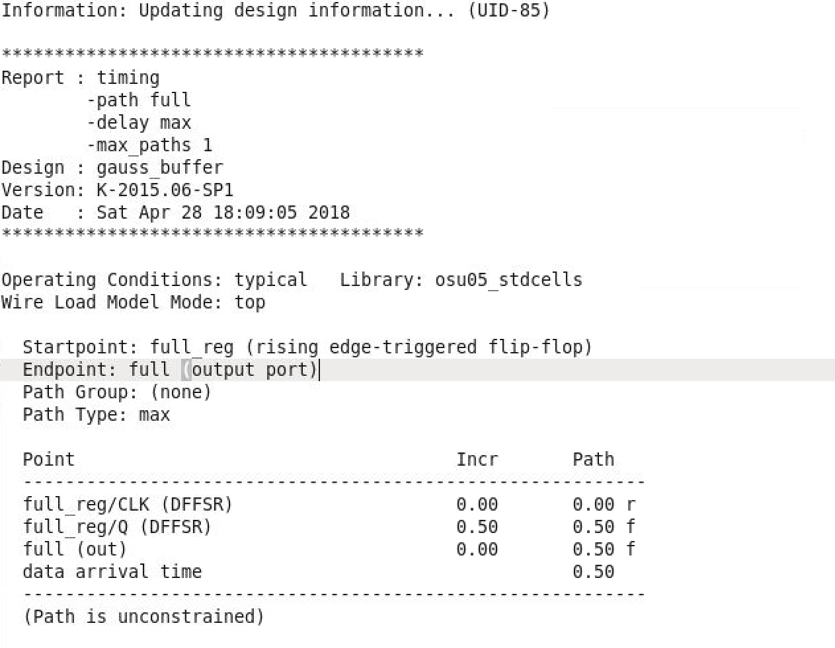

*Figure 35: Timing Report for Gaussian Buffer*

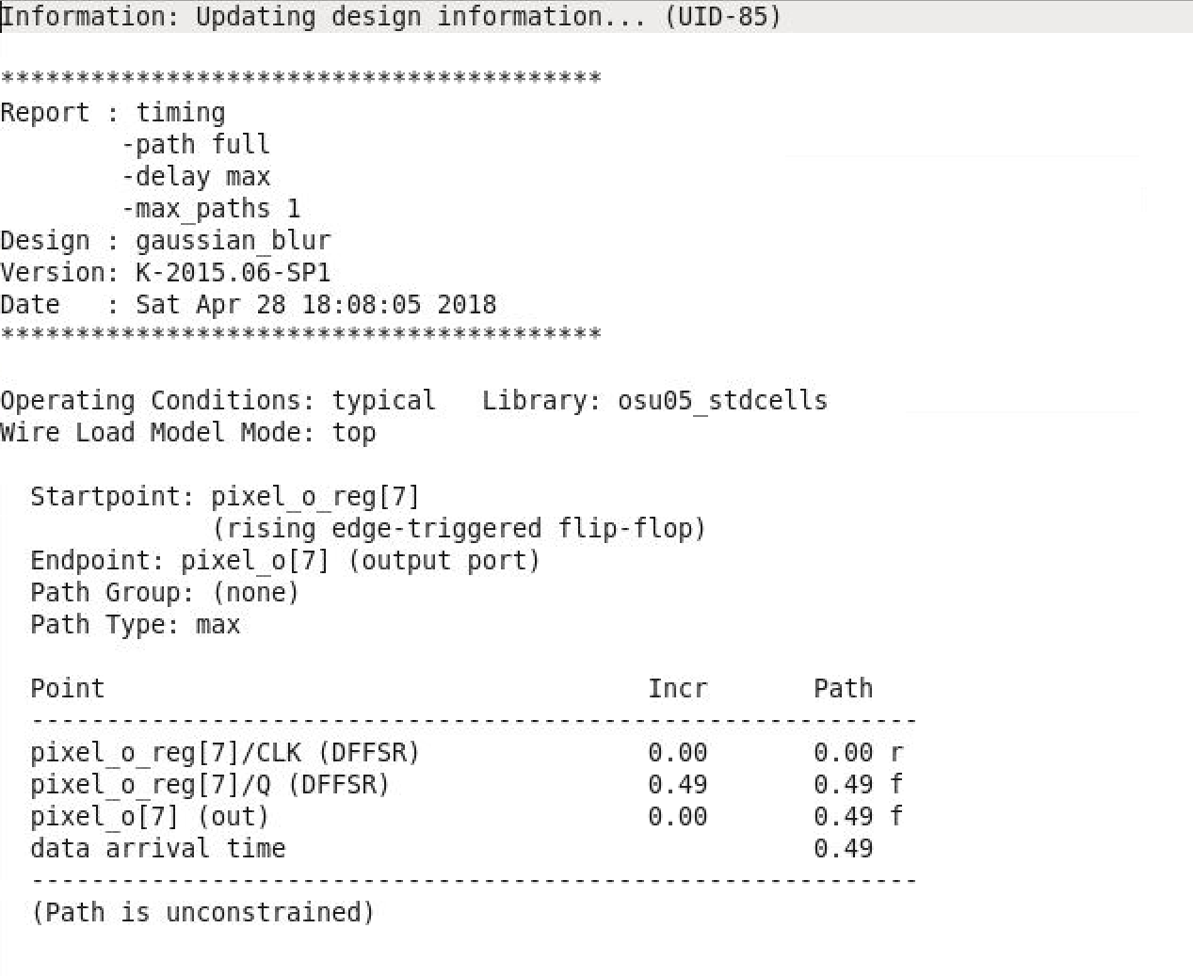

*Figure 36: Timing Report for Gaussian Blur*

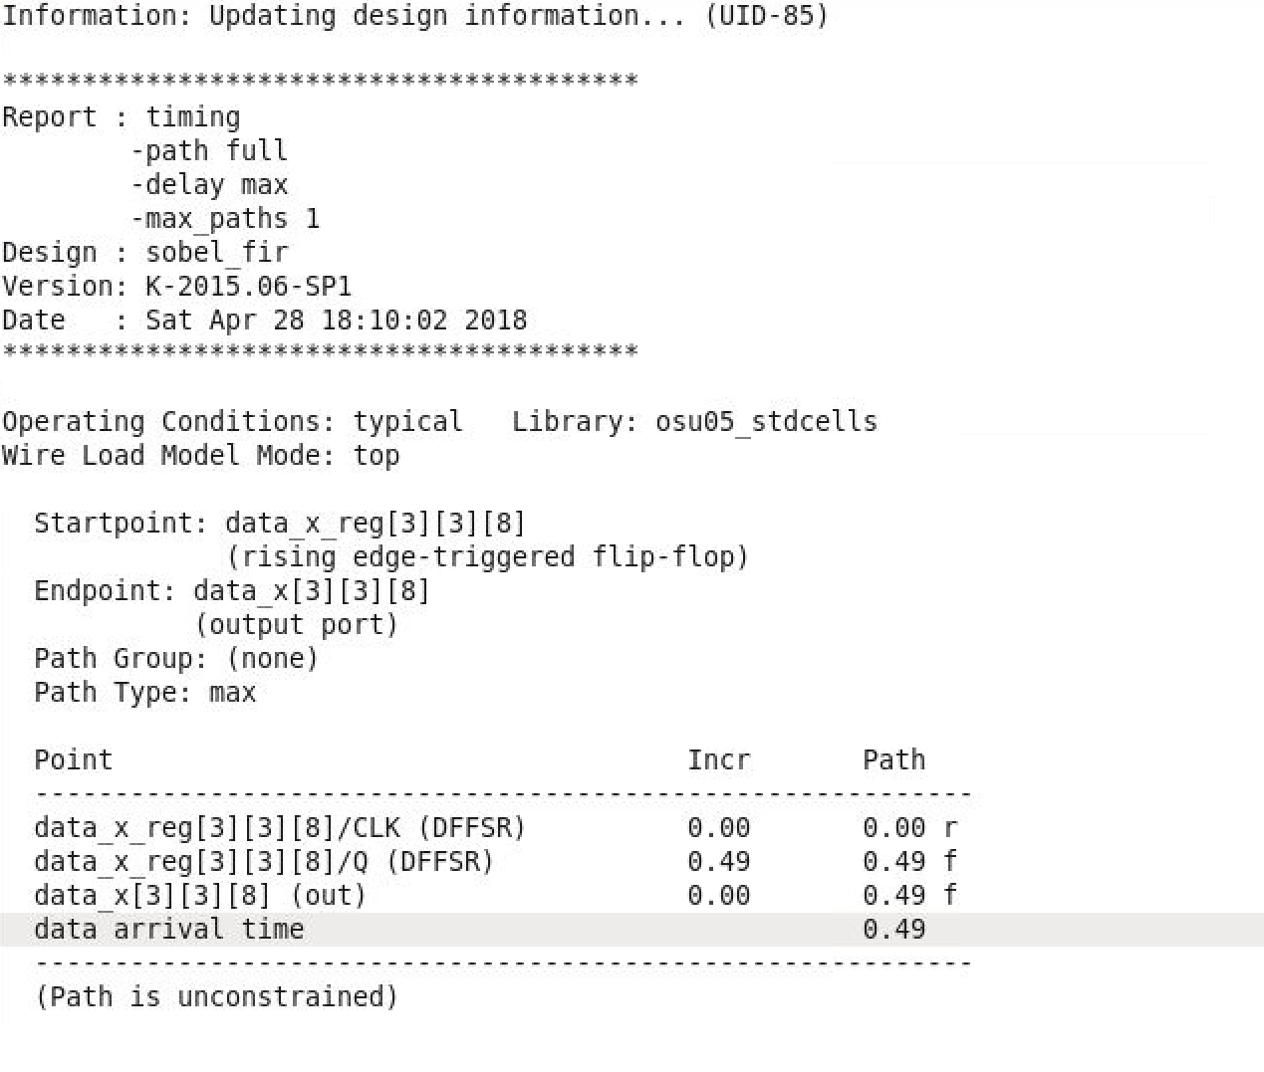

*Figure 37: Timing Report for Sobel Filter*

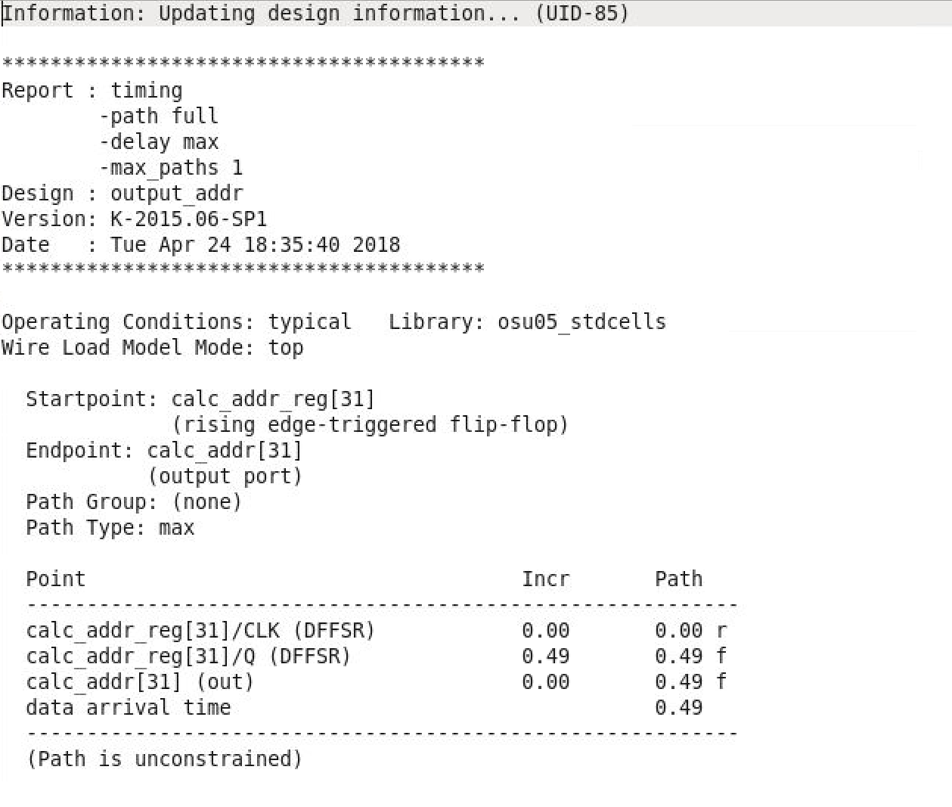

*Figure 38: Timing Report for Output Address*

***4 Success Criteria***

***4.1 Fixed Criteria: (Total of 12 SC Points)***

1. (2 points) Test benches exist for all top-level components and the entire design. The test benches for the entire design can be demonstrated or documented to cover all of the functional requirements given in the design specific success criteria.

Supporting Proof:

1. (2 points) Test Benches exists for all top level components: tb_addr_calc.sv, tb_win_buf.sv, tb_gaussian_blur.sv, tb_gaussian_addr_calc.sv, tb_gaussian_buffer.sv, tb_sobel_fir.sv, tb_magnitude.sv, tb_mag_wrapper.sv tb_gradient.sv, tb_output_addr.sv. (Please see attachments)
2. (4 points) Entire design synthesizes completely, without any inferred latches, timing arcs, and, sensitivity list warnings.

Supporting Proof:

1. (1 points) Finished with the main control unit and the wrapper.
2. (1 points) Run tb_MCU and show the waveform with all the data and state changed.
3. (1 points) File read into the test bench as the form of SRAM.
4. (1 points) SRAM can correctly send the corresponding data out.
5. (2 points) Source and mapped version of the complete design behave the same for all test cases. The mapped version simulates without timing errors except at time zero.

Supporting Proof:

1. (1 points) Source behaved well for all the top level blocks.
2. (1 points) Mapped behaved well for all the top level blocks .
3. (2 points) A complete IC layout is produced that passes all geometry and connectivity checks. The layout is generated with no connectivity warnings or errors.

Supporting Proof:

(2 points) The layout can be successfully generated with no connectivity warnings or errors.

1. (2 points) The entire design complies with targets for area, pin count, throughput (if applicable), and clock rate. The final targets for these parameters will be determined by course staff based on your design review. Failure to reach any of the targets will result a score of 1 out of 2 provided that you are within 50% on area, 10% on pin count, and 25% on throughput. Doing worse in any category will result in a score of 0 out of 2.

Supporting Proof:

1. (1 points) Our targets of area is about 14.2 mm^2 and our actual area is 14.5 mm^2.
2. (1 points) Clock rate is 500 MHz.

***4.2 Design Specific Success Criteria: (Total of 8 SC Points)***

1. (1 points) Demonstrate by simulation of a Verilog test bench that gaussian block works produce the correct blurred pixel given a 3x3 matrix directly from the window buffer.

Supporting Proof:

(1 points) After giving a 3*3 pixel value, the pixel_o value can be correctly calculated.

1. (2 points) Demonstrate by simulation of a Verilog test bench that sobel filter works produce the correct 4x4 matrix of xy sets given a 6x6 blurred pixel matrix from the window buffer.

Supporting Proof:

(1 points)After giving a 6*6 pixel data, sobel_fir block can successfully output two 4*4 matrix for x and y data.

1. (1 points) Demonstrate by simulation of a Verilog test bench that gradient calculator works produce the correct squared valued based on the input xy set.

Supporting Proof:

(1 points) After input two 4*4 pixel matrix, the gradient can successfully output the gradient output value.

1. (2 points) Demonstrate by simulation of a Verilog test bench that the overall function produce the correct grayscale image with all the edges found.

Supporting Proof:

(2 points) The edges of a grayscale image can be successfully found.

1. (2 points) Demonstrate by simulation of a Verilog test bench that the address calculation block calculate the correct address so that data w/r can be implemented correctly. And it should make sure that the window buffer stores the correct 8*8 pixels value.

Supporting Proof:

(2 points) The window buffer can successfully store correct 8*8 pixels value.

***5 Design Verification***

***5.1 Design Verification Overview***

|  |  |  |
| --- | --- | --- |
| DSSC | Test scenario and brief description | Modules involved |
| Demonstrate by simulation of a Verilog test bench that gaussian block works produce the correct blurred pixel given a 3x3 matrix directly from the window buffer. | The input is a 3x3 matrix (from window buffer) and show that the output is just a 8 bit value which is the average value of all the 9 pixels. | Main modules involved: gaussian blur. |
| Demonstrate by simulation of a Verilog test bench that sobel filter works produce the correct 4x4 matrix of xy sets given a 6x6 blurred pixel matrix from the window buffer. | The correct version should be that the input is a 6x6 matrix (from the gaussian buffer) and the output should be 2 4x4 matrix given the sobel algorithm below. The first one is the algorithm for x matrix, and the second one is the algorithm for y matrix.   |  |  |  | | --- | --- | --- | | **-1** | **0** | **1** |  |  | | --- | | **-1** | | **0** | | **1** | | Main modules involved: sobel filter. |
| Demonstrate by simulation of a Verilog test bench that gradient calculator works produce the correct squared valued based on the input xy set. | This is the combination of the magnitude and gradient blocks. So the input are 2 4x4 matrix (from the sobel filter) and the output is a 4x4 matrix with correct x^2+y^2 value calculated. | Main modules involved: magnitude and gradient. |
| Demonstrate by simulation of a Verilog test bench that the address calculation block calculate the correct address so that data w/r can be implemented correctly. And it should make sure that the window buffer stores the correct 8*8 pixels value. | The address calculation block will output the address calculated to SRAM. And then SRAM would send the corresponding data to the window buffer block. And the test bench simulate this process. | Main modules involved: address calculation and window buffer. |
| Demonstrate by simulation of a Verilog test bench that the overall function produce the correct grayscale image with all the edges found. | The correct image can be produced. | Main modules involved: all modules. |

*Table 13: Design verification overview*

***5.2 Test Scenario Breakouts***

***5.2.1 Fixed Criteria: (10.5/12 Points)***

1. (2/2 points) Test benches exist for all top-level components and the entire design. The test benches for the entire design can be demonstrated or documented to cover all of the functional requirements given in the design specific success criteria.

Supporting Proof:

1. (2/2 points) Test Benches exists for all top level components: tb_addr_calc.sv, tb_win_buf.sv, tb_gaussian_blur.sv, tb_gaussian_addr_calc.sv, tb_gaussian_buffer.sv, tb_sobel_fir.sv, tb_magnitude.sv, tb_mag_wrapper.sv tb_gradient.sv, tb_output_addr.sv. (Please see attachments)
2. (3/4 points) Entire design synthesizes completely, without any inferred latches, timing arcs, and, sensitivity list warnings.

Supporting Proof:

1. (1/1 points) Finished with the main control unit and the wrapper. (Please see attachments MCU.sv and edge_detector.sv)
2. (1/1 points) Run tb_MCU and show the waveform with all the data and state changed.
3. (1/1 points) File read into the test bench as the form of SRAM.
4. (0/1 points) SRAM can correctly send the corresponding data out.

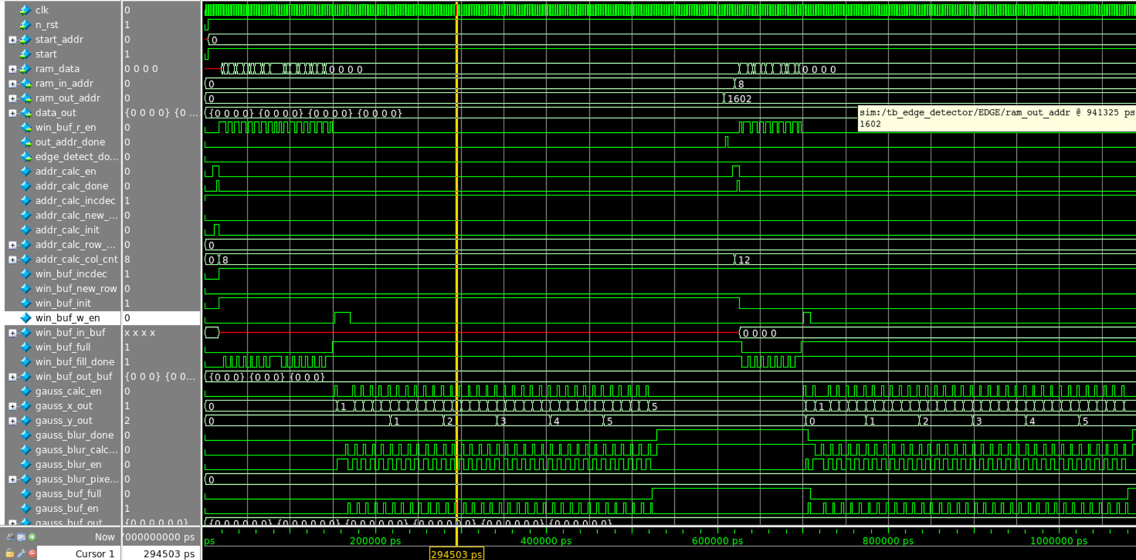

*Figure 39: Timing Diagram for the first start part of edge detector*

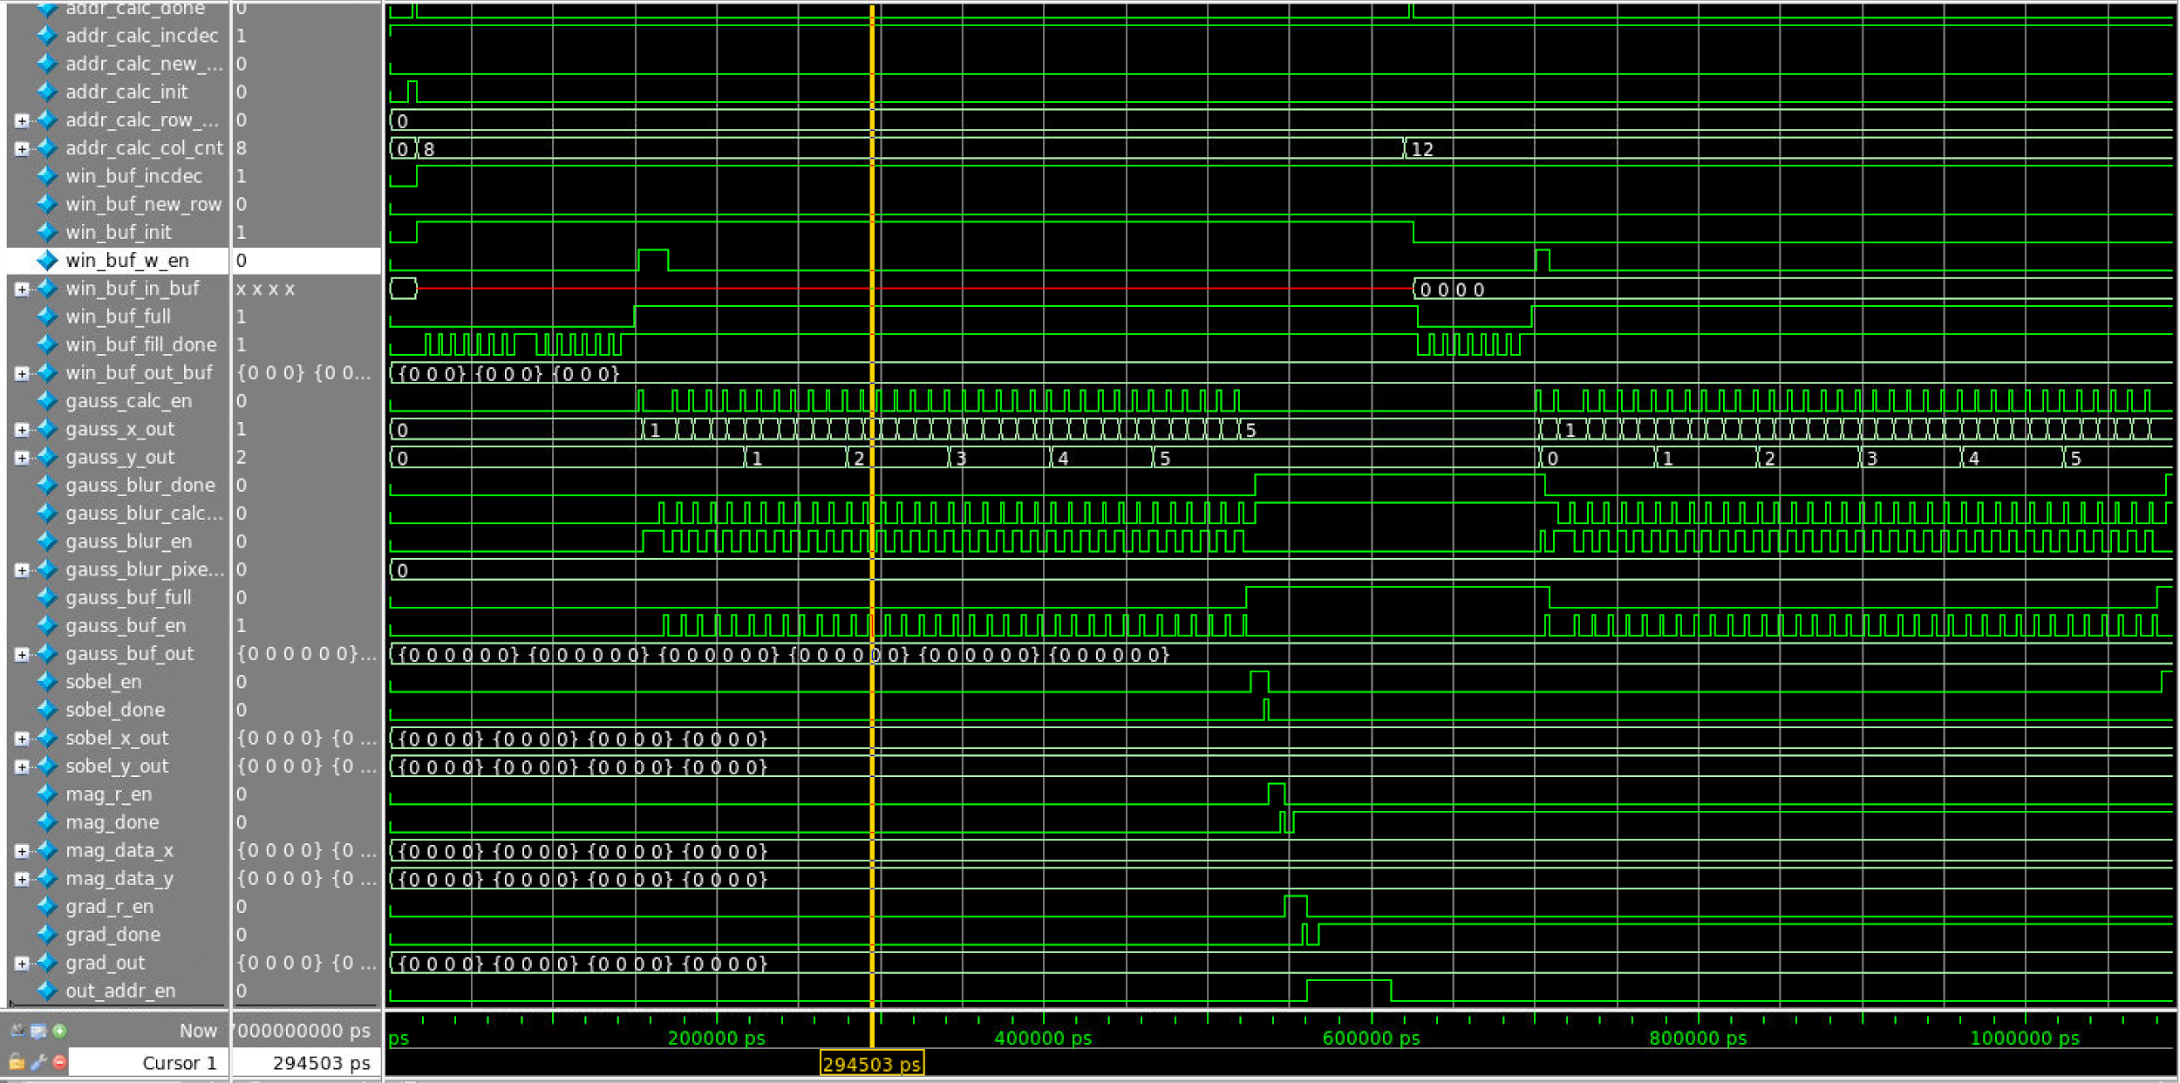

*Figure 40: Timing Diagram for the second start part of edge detector*

The module start after the start signal is asserted by the system. ram_data is read into the module as shown by ram_data signal. The init signal is asserted since it is the first iteration. It is negated immediately after the first iteration. During the first iteration, all 16 win_buf fill is implemented.

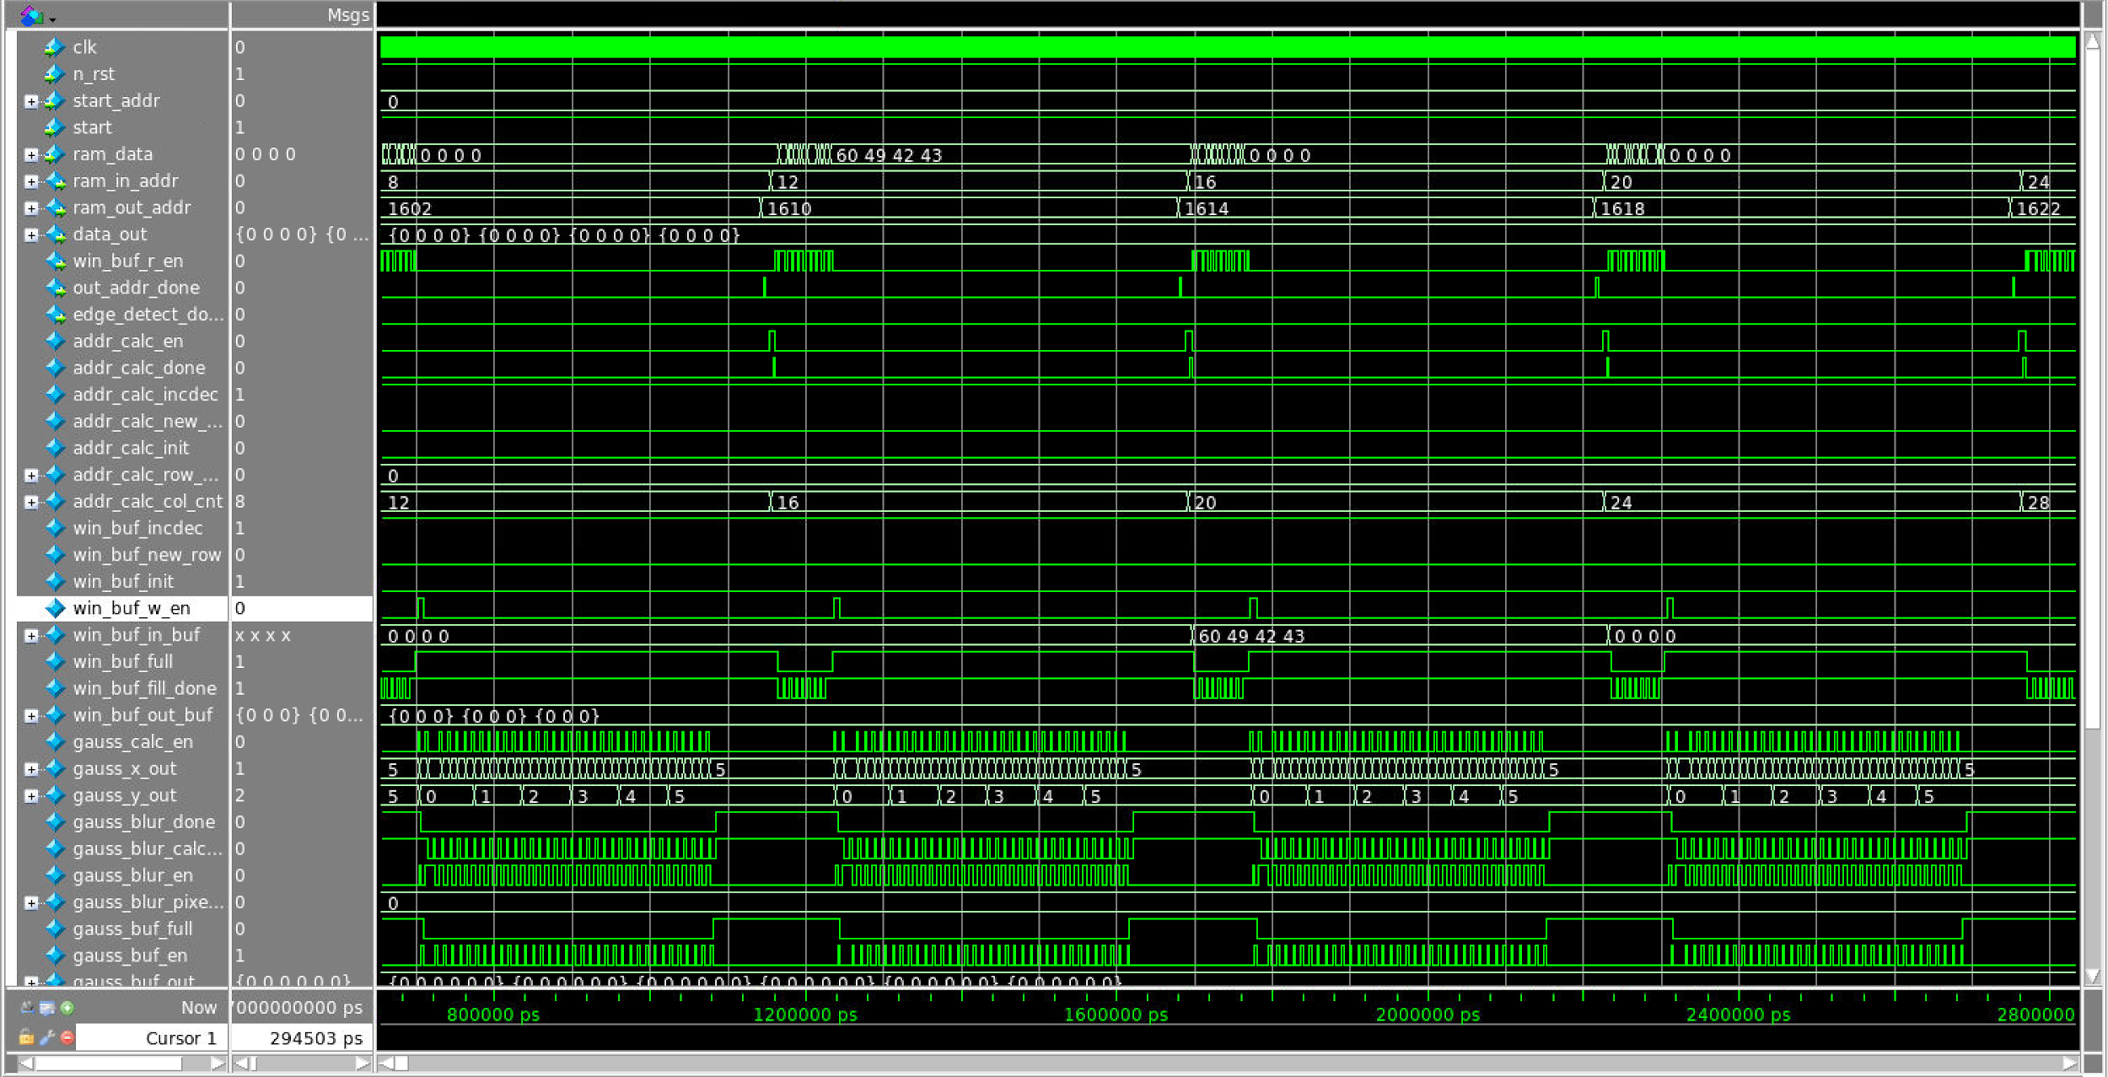

*Figure 41: Timing Diagram for the first middle part of edge detector*

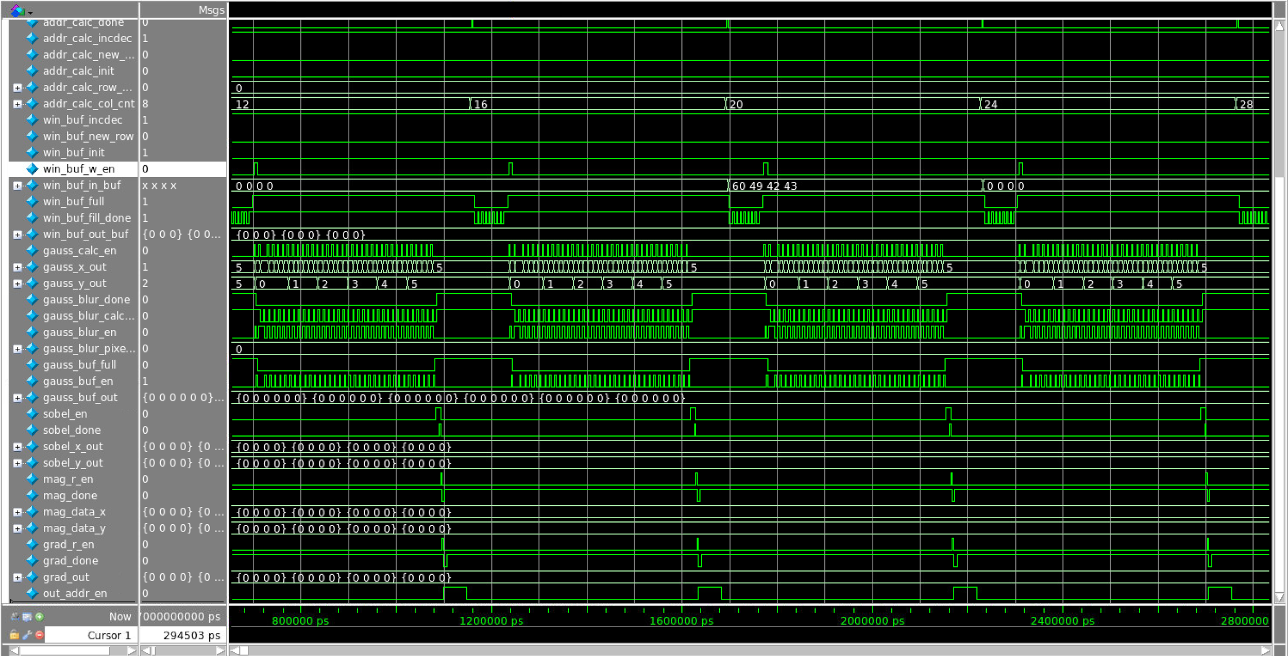

*Figure 42: Timing Diagram for the second middle part of edge detector*

During the mid(normal) phase of the implementation. gaussian blocks is enabled whenever window buffer is finished. Sobel is enable whenever gaussian buffer is full. magnitude module is enable after sobel_fir is done. The gradient module is enabled after the magnitude module is done. The output address module is enabled after the magnitude module is done. The addr_calc is enabled after the output_addr module is done.

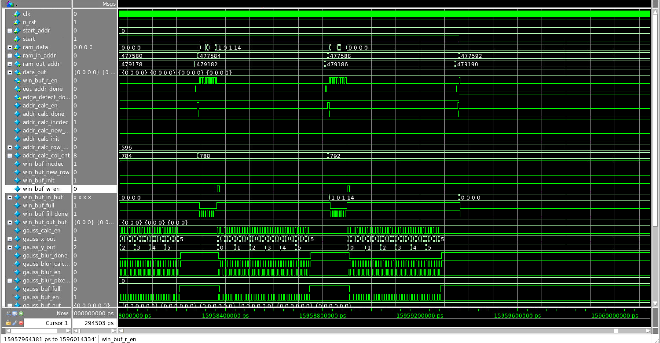

*Figure 43: Timing Diagram for the first end part of edge detector*

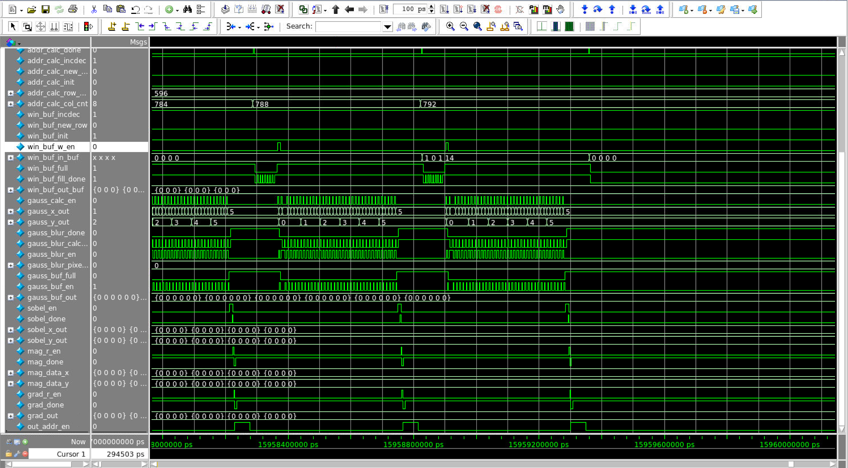

*Figure 44: Timing Diagram for the second end part of edge detector*

This is the end phase of the implementation. The edge_detection_done signal is asserted after the addr_calc provides its last address.

1. (1.5/2 points) Source and mapped version of the complete design behave the same for all test cases. The mapped version simulates without timing errors except at time zero.

Supporting Proof:

1. (1/1 points) Source behaved well for all the top level blocks. (Source behaved well for all the top level blocks.)
2. (0.5/1 points) Mapped behaved well for all the top level block. (All blocks except for window buffer, gaussian blur and output address blocks behave the same for source and mapped version. )
3. (2/2 points) A complete IC layout is produced that passes all geometry and connectivity checks. The layout is generated with no connectivity warnings or errors.

Supporting Proof:

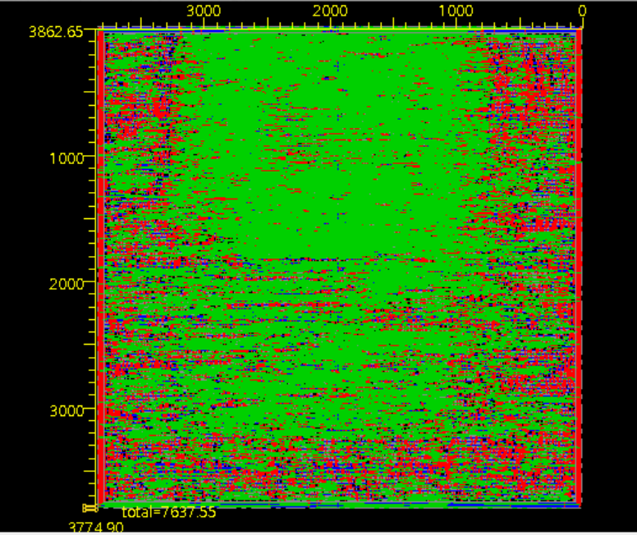

*Figure 45: Layout for the whole design*

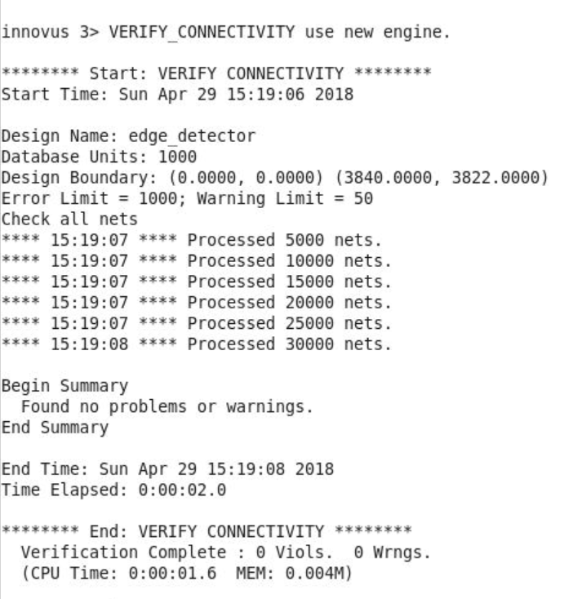

*Figure 46: connectivity for the whole design*

1. (2/2 points) The entire design complies with targets for area, pin count, throughput (if applicable), and clock rate. The final targets for these parameters will be determined by course staff based on your design review. Failure to reach any of the targets will result a score of 1 out of 2 provided that you are within 50% on area, 10% on pin count, and 25% on throughput. Doing worse in any category will result in a score of 0 out of 2.

Supporting Proof:

1. (1/1 points) Our targets of area is about 14.2 mm^2 and our actual area is 14.5 mm^2.
2. (1/1 points) Clock rate is 500 MHz.

***5.2 Design Specific Success Criteria: (6/8 Points)***

1. (1/1 points) Demonstrate by simulation of a Verilog test bench that gaussian block works produce the correct blurred pixel given a 3x3 matrix directly from the window buffer.

Supporting Proof:

After giving a 3*3 pixel value, the pixel_o value is correctly calculated. As the waveform shown below, the total value of summation of data_in at yellow line point is 270. After dividing by 9, we can correctly get 30 as output.



*Figure 47: waveform for Gaussian Blur Block*

1. (2/2 points) Demonstrate by simulation of a Verilog test bench that sobel filter works produce the correct 4x4 matrix of xy sets given a 6x6 blurred pixel matrix from the window buffer.

Supporting Proof:

After giving a 6*6 pixel data, sobel_fir block successfully outputs two 4*4 matrix. As the waveform shown below, after the algorithm for sobel filter, the outputs for both x and y values are correctly calculated.

*Figure 48: waveform for Sobel Filter Block*

1. (1/1 points) Demonstrate by simulation of a Verilog test bench that gradient calculator works produce the correct squared valued based on the input xy set.

Supporting Proof:

After input two 4*4 for x and y values pixel matrix, the gradient can be successfully calculated by the summation of the square of x and square of y.



*Figure 49: waveform for gradient Block*

1. (0/2 points) Demonstrate by simulation of a Verilog test bench that the overall function produce the correct grayscale image with all the edges found.
2. (2/2 points) Demonstrate by simulation of a Verilog test bench that the address calculation block calculate the correct address so that data w/r can be implemented correctly. And it should make sure that the window buffer stores the correct 8*8 pixels value.

addr_calc_win_buf start

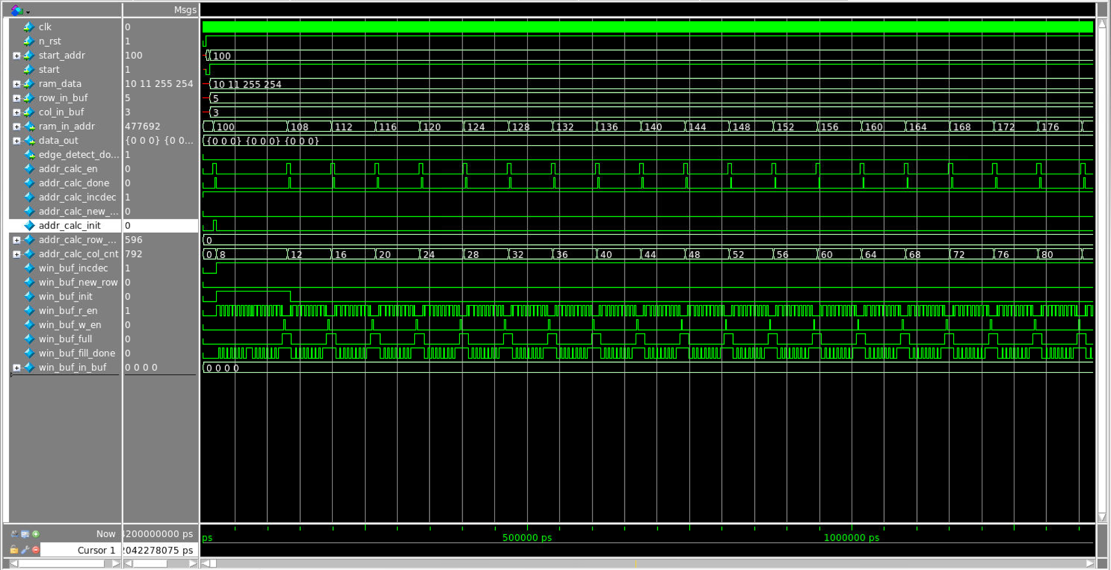

*Figure 50: waveform for initial mode of address calculation and window buffer block*

This is the start phase of addr_calc. The init signal is asserted for the first iteration. During the first iteration all 16 fill states are implemented.

addr_calc_win_buf inc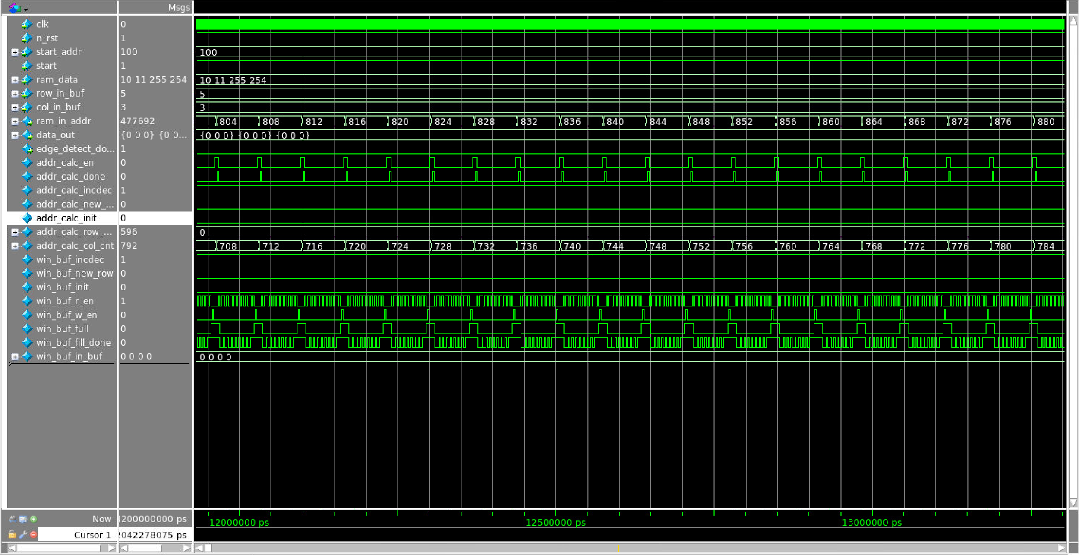

*Figure 51: waveform for increasing mode of address calculation and window buffer block*

This is the increasing case of addr_calc. The incdec signal is asserted. calc_done is asserted after every filling iteration. col_cnt is increasing(i.e. the window buffer is going to the right).

addr_calc_win_buf dec

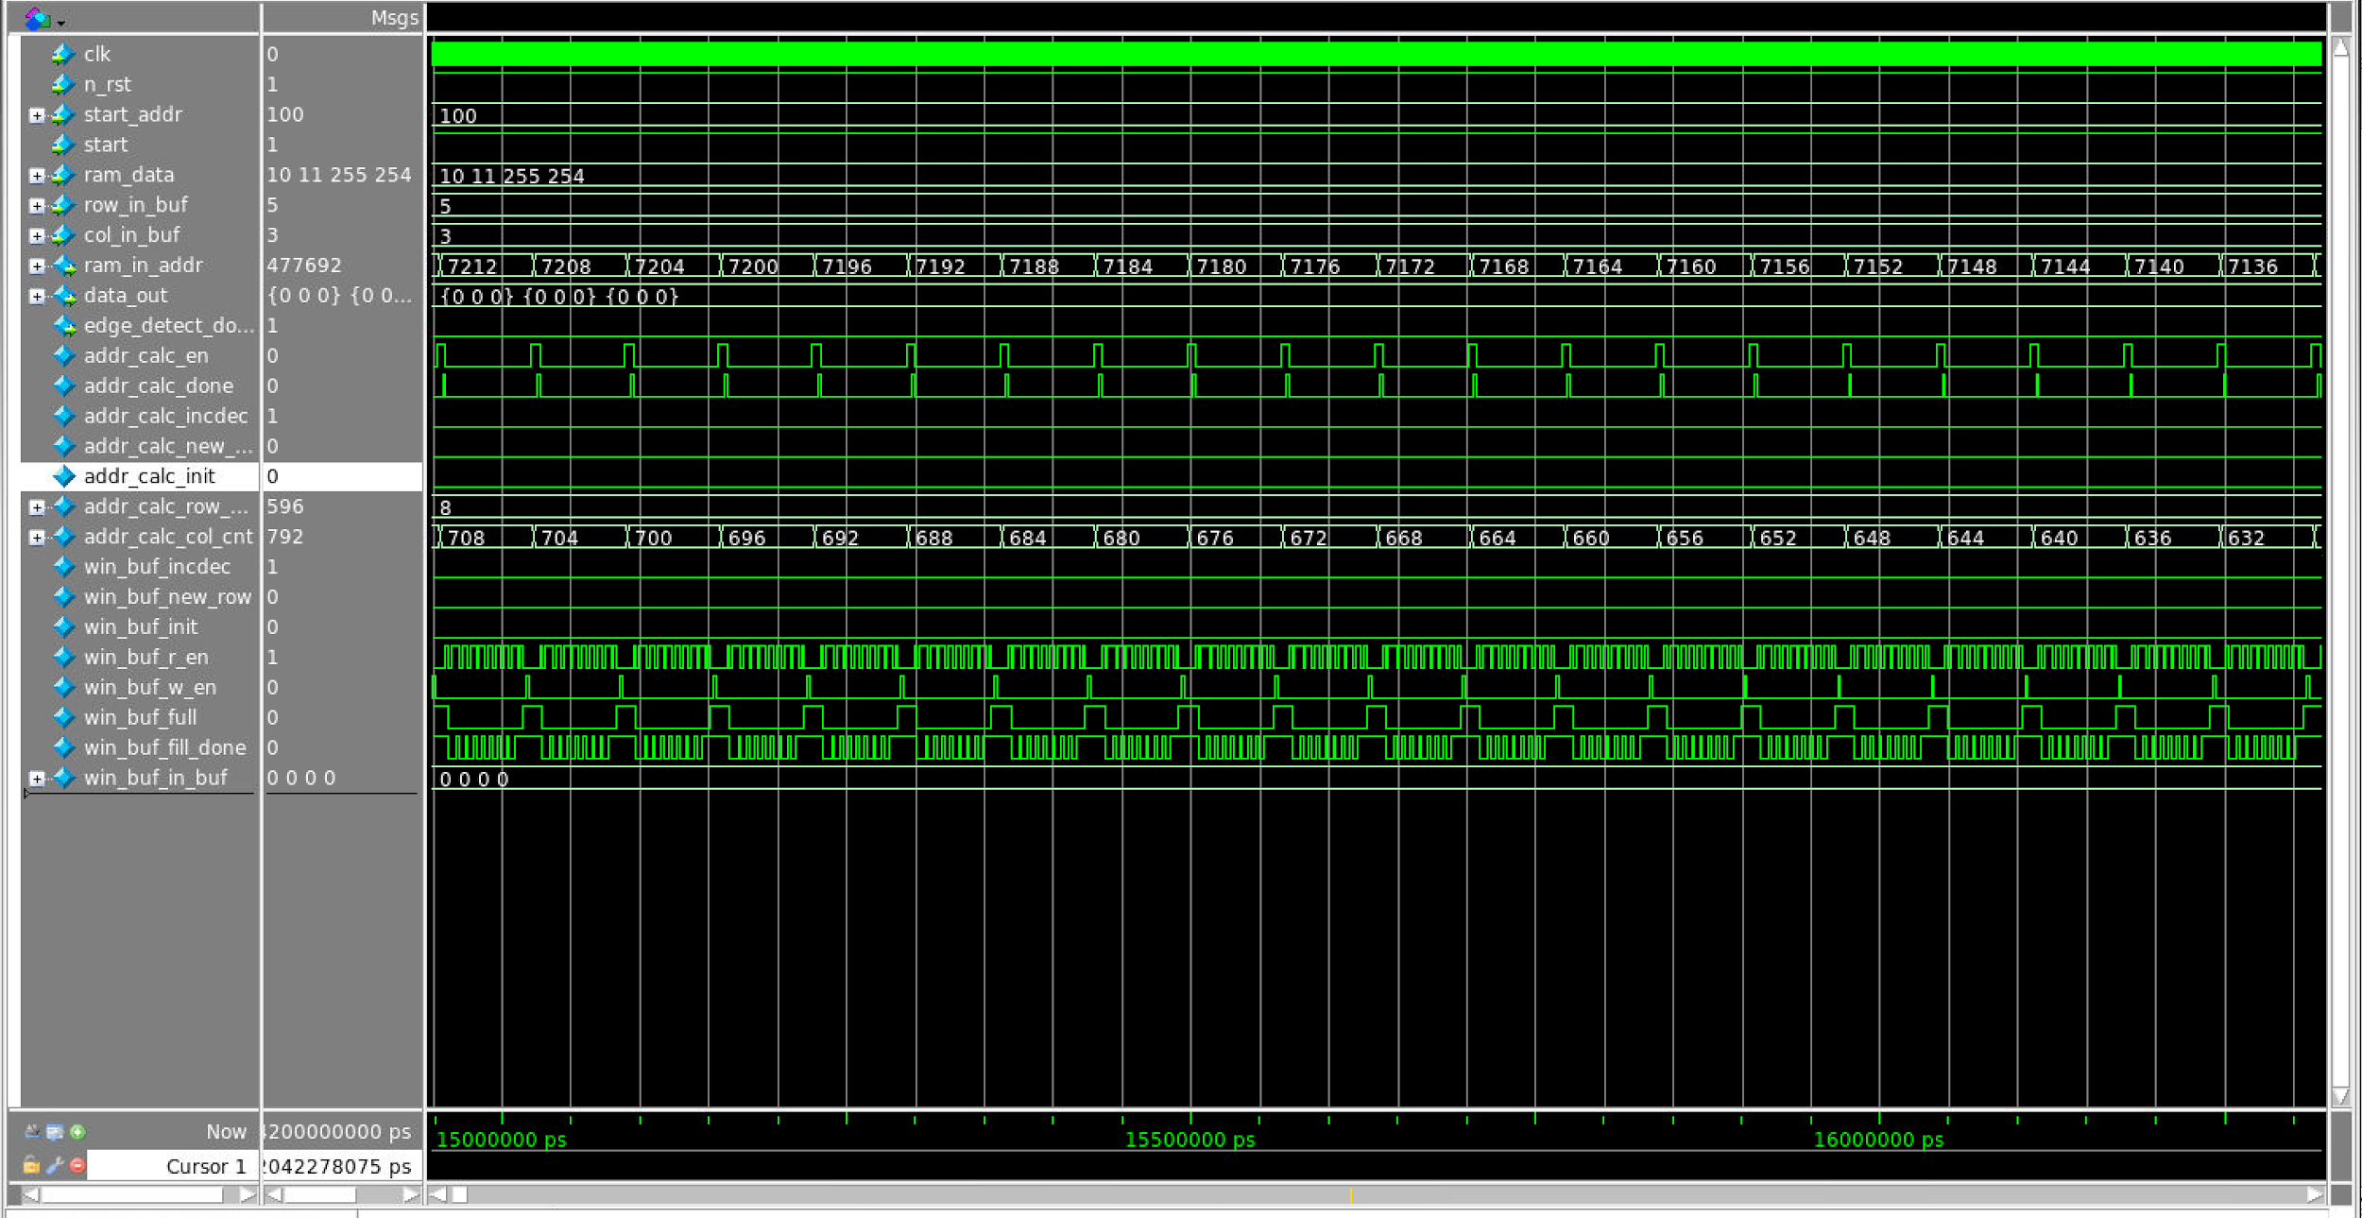

*Figure 52: waveform for decreasing mode of address calculation and window buffer block*

This is the increasing case of addr_calc. The incdec signal is negated. calc_done is asserted after every filling iteration. col_cnt is decreasing(i.e. the window buffer is going to the left).

addr_calc_win_buf new row

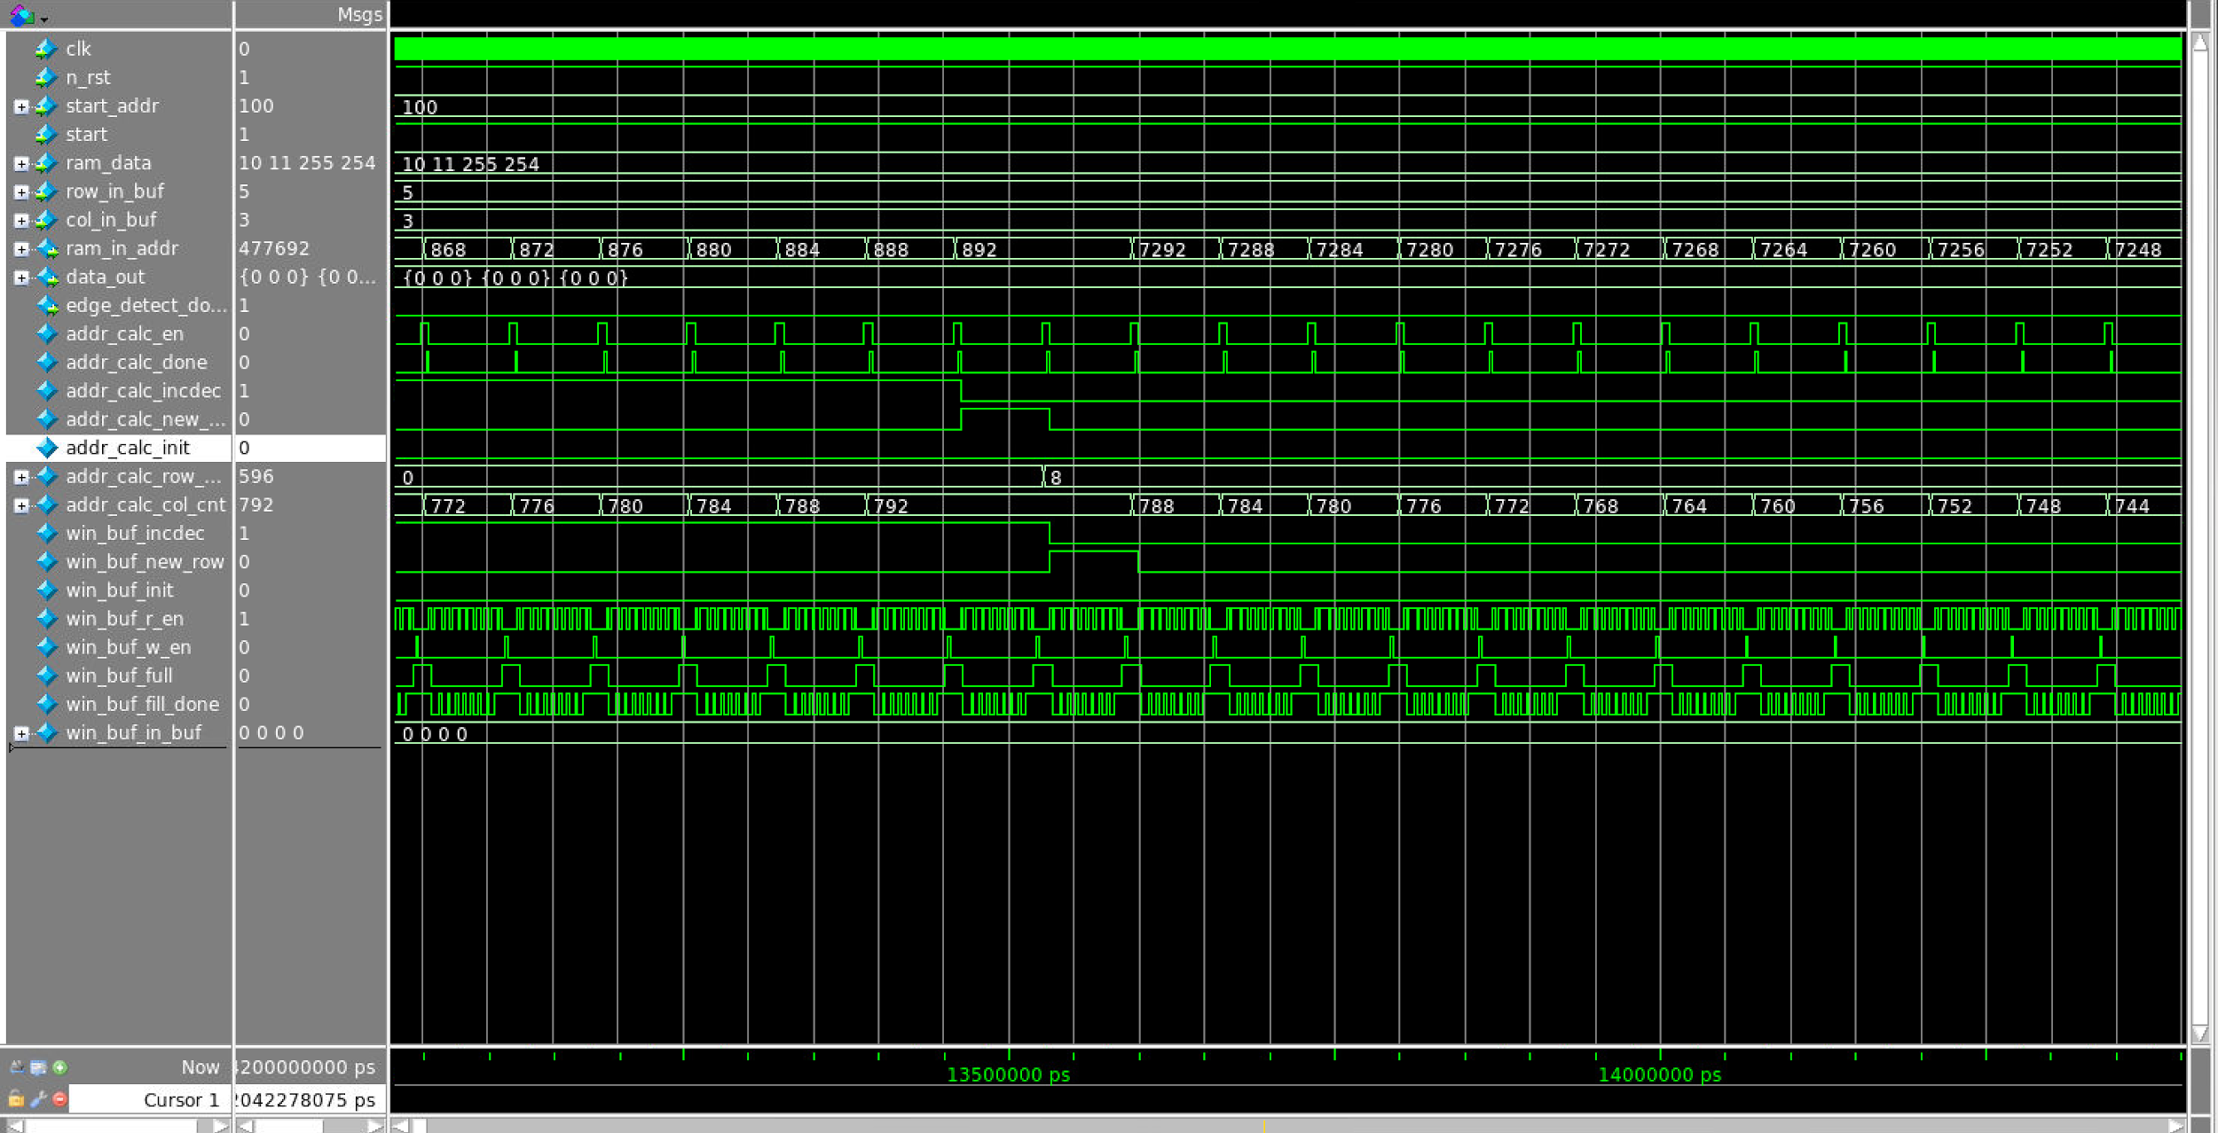

*Figure 53: waveform for new row mode of address calculation and window buffer block*

This is the new row case of addr_calc. The new_row signal is asserted. calc_done is asserted after every filling iteration. row_cnt is increased (i.e. the window buffer is going down).

addr_calc_win_buf end

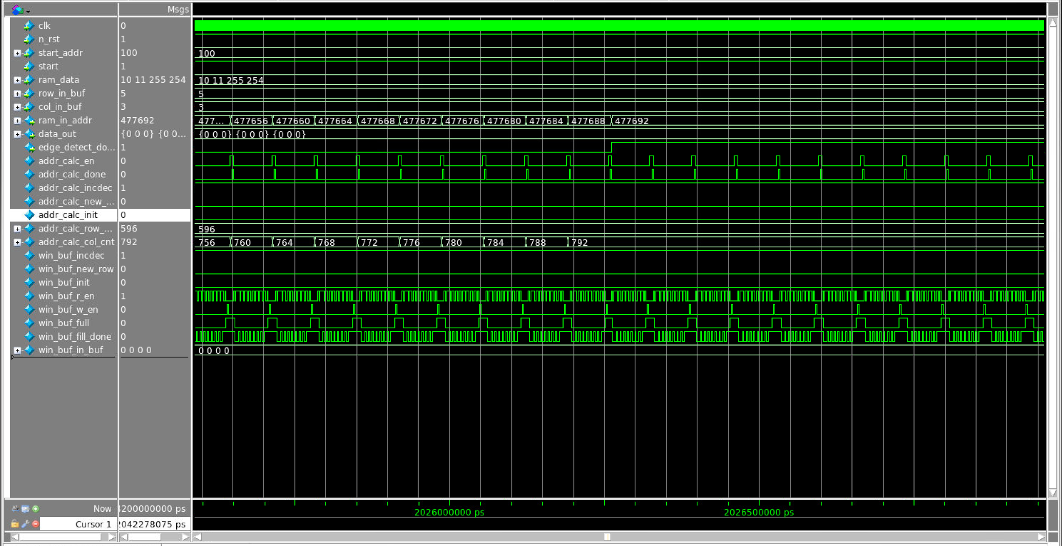

*Figure 53: waveform for end part of address calculation and window buffer block*

This is the end phase of the addr_calc. The finish signal is asserted after the counter reaches the last block of the image.

***6 Project Management***

|  |  |
| --- | --- |
| Block | Person on duty |
| Address Calculation | Haobo Chen, Ni Kang |
| Window Buffer | Haobo Chen |
| Gaussian Address Calculation | Haoming Zhang |
| Gaussian Buffer | Haoming Zhang |
| Gaussian Blur | Haoming Zhang |
| Sobel Filter | Ni Kang, Haoming Zhang |
| Magnitude | Haobo Chen, Haoming Zhang |
| Gradient | Haobo Chen, Haoming Zhang |
| Output Address | Ni Kang |

*Table 14: Project management*

APPENDIX A

***Account and directory where all of the files are located: mg119/ece337/ECE337Project***

Design Verilog Code Modules:

* Top level structural Verilog Code: source/edge_detector.sv
* Control Unit: source/MCU.sv
* Address Calculation Block: source/addr_calc.sv
* Window Buffer Block: source/win_buf.sv
* Address Calculation and Window Buffer Block: source/addr_calc_win_buf.sv
* Gaussian Address Calculation Block: source/gauss_addr_calc.sv
* Gaussian Blur Block: source/gauss_blur.sv
* Gaussian Buffer Block: source/gauss_buffer.sv
* Sobel Filter Block: source/sobel_fir.sv
* Magnitude Block: source/magnitude.sv
* Gradient Block: source/gradient.sv
* Gradient and Magnitude Block: source/mag_mcu.sv
* Output Address Block: source/output_addr.sv

Test Benches:

* Test of top level: source/tb_edge_detector.sv
* Test of control Unit: source/tb_mcu.sv
* Test of Address Calculation Block: source/tb_addr_calc.sv
* Test of Window Buffer Block: tb_win_buf.sv
* Test of Address Calculation and Window Buffer Block: source/tb_addr_calc_win_buf.sv
* Test of Gaussian Address Calculation Block: source/tb_gauss_addr_calc.sv
* Test of Gaussian Blur Block: source/tb_gauss_blur.sv
* Test of Gaussian Buffer Block: source/tb_gauss_buffer.sv
* Test of Sobel Filter Block: source/tb_sobel_fir.sv
* Test of Magnitude Block: source/tb_magnitude.sv
* Test of Gradient Block: source/tb_gradient.sv
* Test of Gradient and Magnitude Block: source/tb_mag_mcu.sv
* Test of Output Address Block: source/tb_output_addr.sv

Report:

* Top level structural Verilog Code: reports/edge_detector.rep
* Control Unit: reports/MCU.rep
* Address Calculation Block: reports/addr_calc.rep
* Window Buffer Block: reports/win_buf.rep
* Address Calculation and Window Buffer Block: reports/addr_calc_win_buf.rep
* Gaussian Address Calculation Block: reports/gauss_addr_calc.rep
* Gaussian Blur Block: reports/gauss_blur.rep
* Gaussian Buffer Block: reports/gauss_buffer.rep
* Sobel Filter Block: reports/sobel_fir.rep
* Magnitude Block: reports/magnitude.rep
* Gradient Block: reports/gradient.rep
* Gradient and Magnitude Block: reports/mag_mcu.rep
* Output Address Block: reports/output_addr.rep

**Reference Data Sheet:**

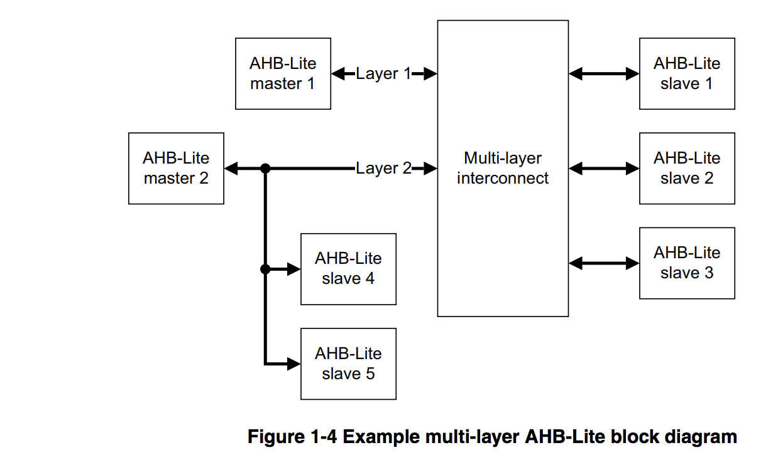

|  |  |
| --- | --- |
| **Name** | **Description** |
| **HCLK** | The bus clock times all bus transfers. All signal timings are related to the rising edge of HCLK. |
| **HRESETn** | The bus reset signal is active LOW and resets the system and the bus. This is the only active LOW AHB-Lite signal. |

